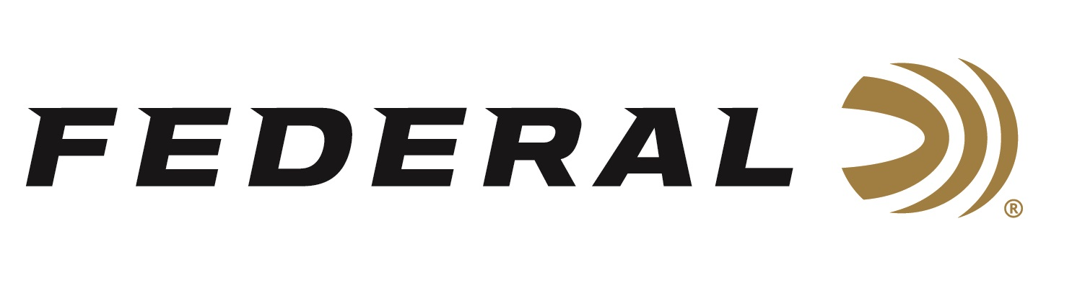

FOR IMMEDIATE RELEASE

Federal Custom Shop Launches Special Edition Ammunition for Springfield Model 2020 Waypoint Rifle

ANOKA, Minnesota – November 28, 2022 – Federal is proud to announce its Springfield Armory Model 2020 Waypoint Special Edition ammunition is now available from its Online Custom Shop. A dedicated webpage takes Custom Shop users to an order form, where they select their bullet options and caliber, then purchase the handloaded ammunition direct at: Custom Shop Waypoint 2020 (federalpremium.com).

“The new Model 2020 Waypoint rifle from Springfield represents a level of features and customization you won’t find in other factory firearms. It’s only fitting that Federal Custom Shop would offer loads specifically built for the revolutionary platform,” said Federal Ammunition’s Marketing Director Brian Anderson. “Shoppers can now choose from several Custom Shop offerings loaded with Terminal Ascent and Nosler AccuBond bullets and optimized for the best ballistics and overall performance from their Model 2020 Waypoint rifle.”

Watch video here: https://youtu.be/RWqRRAEfVIU

The Federal ammunition plant is in Anoka, Minnesota, and its online Custom Shop is a separate, secured room inside the massive factory. It is a state-of-the-art reloading workshop focused on the utmost attention to detail, quality and care for each hand-loaded round produced. An elite group of Federal’s most experienced employees were selected to work in the Custom Shop. Using the best components available, these expert engineers handcraft this ammunition to order. Each round is hand-checked with a final cleaning and inspection before being packed in Custom Shop packaging and shipped out. Each box of Custom Shop ammunition is signed by the Federal employee who hand-loaded it. Since this ammunition is made-to-order, typical lead time is approximately two weeks.

Springfield Armory Model 2020 Waypoint is precision manufactured in the USA. Each Model 2020 is built to deliver the accuracy and performance expected from a custom-grade rifle. The Model 2020 Waypoint features a carbon fiber stock and a steel or carbon fiber barrel with an impressive .75 MOA accuracy guarantee.

Federal ammunition can be found at dealers nationwide. For more information on all products from Federal or to shop online, visit www.federalpremium.com.
Press Release Contact: JJ Reich
Senior Manager – Press Relations
E-mail: VistaPressroom@VistaOutdoor.com

About Federal Ammunition
Federal, headquartered in Anoka, MN, is a brand of Vista Outdoor Inc., an outdoor sports and recreation company. From humble beginnings nestled among the lakes and woods of Minnesota, Federal Ammunition has evolved into one of the world's largest producers of sporting ammunition. Beginning in 1922, founding president, Charles L. Horn, paved the way for our success. Today, Federal carries on Horn's vision for quality products and service with the next generation of outdoorsmen and women. We maintain our position as experts in the science of ammunition production. Every day we manufacture products to enhance our customers' shooting experience while partnering with the conservation organizations that protect and support our outdoor heritage. We offer thousands of options in our Federal Premium and Federal® lines-it's what makes us the most complete ammunition company in the business and provides our customers with a choice no matter their pursuit.

