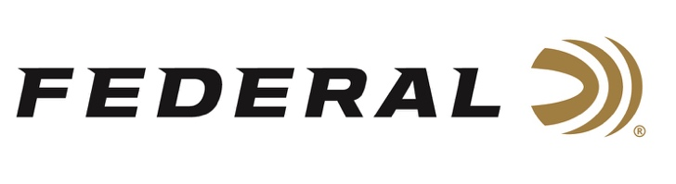

FOR IMMEDIATE RELEASE

DeTavernier Wins the Women’s Doubles Trap Division at the 2022 ACUI Collegiate National Championships

ANOKA, Minnesota – March 29, 2022 – The 2022 ACUI Collegiate Clay Targets National Championships was recently held in San Antonio, Texas. Federal Ammunition sponsored shooter Payton DeTavernier won the Women’s Doubles Trap Division and also claimed the Combined American Trap Events Overall Title. DeTavernier, now a national champion, is a college student on the Shooting Sports Shotgun Team at Doane University in Nebraska.

“This championship win was something I really wanted and I couldn’t be happier,” said DeTavernier. “I have worked extremely hard to accomplish this and I wouldn’t have been able to do it without my parents, Federal Ammunition, and my other sponsors. It means so much to me that I have an amazing support system and people who are always there to help me.”

DeTavernier brought home two individual national championships in the women's divisions. She posted a score of 99 in Doubles American Trap to win Category 2. In Combined American Trap Events, DeTavernier had a combined score of 196 to claim the Overall Title. Final match results revealed that she placed 14th overall in the women's division with a total High Overall (HOA) score of 514. There were only 150 women's shooters to hit at least 200 targets to make the standings board.

“I shot Federal Top Gun loads at the ACUI Collegiate Clay Targets National Championships this year. I have always trusted and liked them,” said Detavernier. “However, for upcoming ATA competitions and for practice purposes, I will shoot the new Federal High Over All. I love these new HOA loads because they are a Premium load that shoots the same every time. I can see the precision in my breaks and my scores, these loads are awesome.”

Engineered for elite trap, skeet and sporting clays shooters, Federal Premium High Over All features a hard, high-antimony lead payload and an exclusive one-piece Podium wad. The new load produces the most consistent patterns, while the solid brass head and tapered, one-piece hull make reloading easier than ever.

For more information on all products from Federal or to shop online, visit www.federalpremium.com.

(DeTavernier is pictured in the center with her Doane University teammates.)

Press Release Contact: JJ Reich
Senior Manager – Press Relations
E-mail: VistaPressroom@VistaOutdoor.com

About Federal Ammunition
Federal, headquartered in Anoka, MN, is a brand of Vista Outdoor Inc., an outdoor sports and recreation company. From humble beginnings nestled among the lakes and woods of Minnesota, Federal Ammunition has evolved into one of the world's largest producers of sporting ammunition. Beginning in 1922, founding president, Charles L. Horn, paved the way for our success. Today, Federal carries on Horn's vision for quality products and service with the next generation of outdoorsmen and women. We maintain our position as experts in the science of ammunition production. Every day we manufacture products to enhance our customers' shooting experience while partnering with the conservation organizations that protect and support our outdoor heritage. We offer thousands of options in our Federal Premium and Federal® lines-it's what makes us the most complete ammunition company in the business and provides our customers with a choice no matter their pursuit.

###

