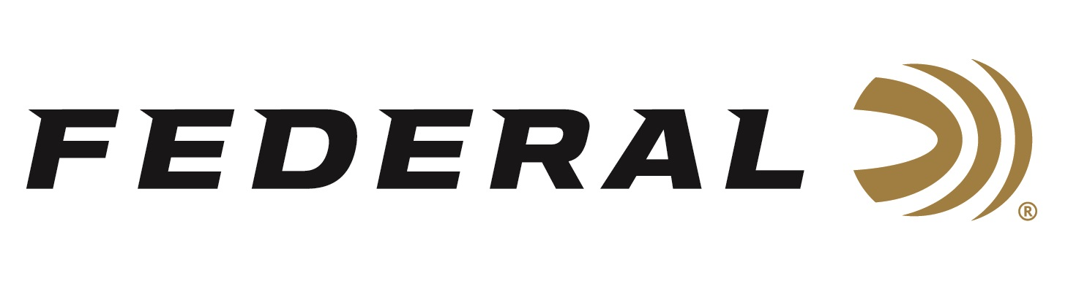
FOR IMMEDIATE RELEASE

Competitive Sporting Clays Shooter Derrick Mein Wins Federal Ammunition’s HOA Cup 400

ANOKA, Minnesota – June 17, 2022 – Federal Ammunition sponsored shooter Derrick Mein won the Federal HOA Cup 400 hosted by Game Unlimited Hunting Club and Sporting Clays in Hudson, Wisconsin, held June 10-12. Federal was the title sponsor for the event which included a 200-target Main Event, 100-target FITASC, 50-target 5-Stand and 50-target Super Sport.

Mein won 1st Place in the High Overall scoring. He won the Main Event and the Super Sport event. He also took 2nd in 5-Stand and 5th in FITASC.

“The difficulty of the targets put an extra need for confidence in my ammo,” said Mein. “Federal HOA and Gold Medal Papers were up to the task providing solid consistent breaks even on the longest of targets, which allowed me to focus on putting the shot on target.”

Team Federal’s Gregg Wolf also had an impressive performance. Wolf won 3rd Place in the High Overall scoring and He placed 4th in the Main Event.

“Mein and Wolf were certainly two of the top shooters of the weekend,” said Federal’s Vice President of Marketing Jason Nash. “It’s incredible to see shooters in the Master class division shoot so well with our products. HOA is great ammo, and this event highlighted its winning capabilities. We congratulate Team Federal on these accomplishments and look forward to seeing more successes at upcoming matches all summer long.”

Engineered for the most elite trap, skeet, and sporting clays shooters, Federal Premium High Over All leaves a trail of shattered targets in its wake and more reloads per shell. It’s hard, high-antimony lead payload and exclusive one-piece Podium wad produce the most consistent patterns, while the solid brass head and tapered, one-piece hull make reloading easier than ever. It's the ultimate competition load for the world's best shooters.

Federal ammunition can be found at dealers nationwide or purchased online direct from Federal. For more information on all products from Federal or to shop online, visit www.federalpremium.com.

Pictured: Derrick Mein with Jason Vanderbrink, President of Federal and Remington Ammunition.

Press Release Contact: JJ Reich
Senior Manager – Press Relations
E-mail: VistaPressroom@VistaOutdoor.com

About Federal Ammunition
Federal, headquartered in Anoka, MN, is a brand of Vista Outdoor Inc., an outdoor sports and recreation company. From humble beginnings nestled among the lakes and woods of Minnesota, Federal Ammunition has evolved into one of the world's largest producers of sporting ammunition. Beginning in 1922, founding president, Charles L. Horn, paved the way for our success. Today, Federal carries on Horn's vision for quality products and service with the next generation of outdoorsmen and women. We maintain our position as experts in the science of ammunition production. Every day we manufacture products to enhance our customers' shooting experience while partnering with the conservation organizations that protect and support our outdoor heritage. We offer thousands of options in our Federal Premium and Federal® lines-it's what makes us the most complete ammunition company in the business and provides our customers with a choice no matter their pursuit.

