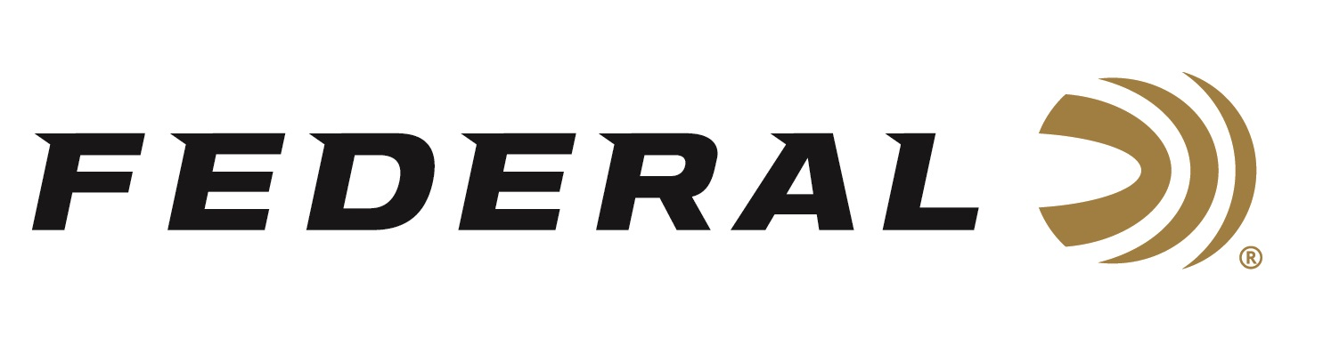

FOR IMMEDIATE RELEASE

Constructing a Retriever on “It’s Federal Season” Podcast

ANOKA, Minnesota – August 11, 2022 – Chad Belding, host of The Fowl Life on Outdoor Channel, is the host of this episode of “It’s Federal Season” podcast. Belding is joined by Mossy Pond Retrievers Brad Arington for a discussion on selecting and training a waterfowl dog.

“Brad is one of the top waterfowl dog trainers in the country,” stated Chad Belding, television host. “I am fortunate that he trained and continues to work with Axel, my Labrador retriever featured on episodes of The Fowl Life television show.”

The conversation between the two waterfowl enthusiasts includes puppy selection, breed choices, tips on training, and training regimens to consider when getting your blind companion ready for the season. The duo also discusses dual purpose dogs and what breeds are appropriate for both the waterfowl and upland arenas.

“Brad brings a great perspective and insights into building a hunting buddy as well as a great family pet,” concluded Belding.

Episode #38 “Constructing a Retriever”
https://www.federalpremium.com/this-is-federal/podcast/

For this episode, besides listening on the Federal Premium website or Talk North podcast network, you can also subscribe to Federal Ammunition’s YouTube channel (https://www.youtube.com/user/federalpremiumammo) and tune in for the discussion.

Federal Ammunition can be found at dealers nationwide or purchased online direct from Federal. For more information on all products from Federal or to shop online, visit www.federalpremium.com.

Press Release Contact: JJ Reich
Senior Manager – Press Relations
E-mail: VistaPressroom@VistaOutdoor.com

About Federal Ammunition
Federal, headquartered in Anoka, MN, is a brand of Vista Outdoor Inc., an outdoor sports and recreation company. From humble beginnings nestled among the lakes and woods of Minnesota, Federal Ammunition has evolved into one of the world's largest producers of sporting ammunition. Beginning in 1922, founding president, Charles L. Horn, paved the way for our success. Today, Federal carries on Horn's vision for quality products and service with the next generation of outdoorsmen and women. We maintain our position as experts in the science of ammunition production. Every day we manufacture products to enhance our customers' shooting experience while partnering with the conservation organizations that protect and support our outdoor heritage. We offer thousands of options in our Federal Premium and Federal® lines-it's what makes us the most complete ammunition company in the business and provides our customers with a choice no matter their pursuit.

