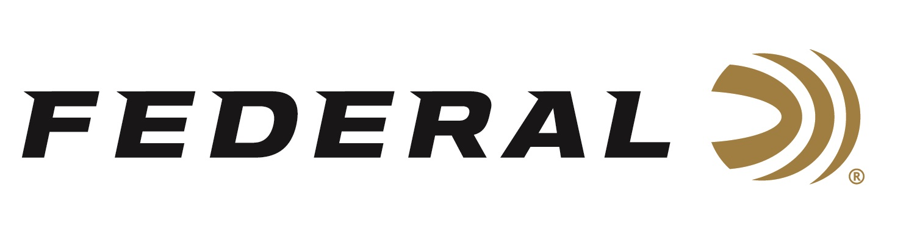

FOR IMMEDIATE RELEASE

Ukraine T-Shirt Sales Generate a $100,000 Donation

ANOKA, Minnesota – May 13, 2022 – Federal Ammunition along with sister brand Remington Ammunition is proudly sending a check of $100,000 in support of crisis relief for the citizens of the war-torn country of Ukraine. A t-shirt campaign supporting the relief efforts generated great response and the proceeds from the sales reached the milestone in less than two months.

“This campaign and the tremendous response exceeded our expectations forcing several re-orders of the t- shirts,” says Jason Vanderbrink, President of Federal Ammunition, Remington, CCI, Speer. "I’m so proud of our loyal customers for being willing to pitch in and support the people of Ukraine who are suffering because of the horrors of war. Our ammunition brands are proud to do our part," continued Vanderbrink.

The t-shirt design, available at www.federalpremium.com/merchandise/apparel/ and www.remington.com/merchandise/apparel/, features the call out from the Ukrainian President needing ammunition to assist in their country’s defense.

The t-shirts continue to receive a tremendous amount of support and are selling out quickly. If the desired shirt in six sizes from 3XL to small sell out, consumers can sign up to receive a notification of when the t-shirt has been restocked.

The $100,000 donation will go to support the humanitarian relief efforts through Ukraine Crisis Relief Fund - GlobalGiving. Federal, along with sister ammunition brands CCI, Speer, and Remington, also donated a total of one million rounds to the Ukraine armed forces.

Federal ammunition can be found at dealers nationwide or purchased online direct from Federal. For more information on all products from Federal or to shop online, visit www.federalpremium.com.

Press Release Contact: JJ Reich
Senior Communications Manager - Ammunition
E-mail: VistaPressroom@VistaOutdoor.com

About Federal Ammunition
Federal, headquartered in Anoka, MN, is a brand of Vista Outdoor Inc., an outdoor sports and recreation company. From humble beginnings nestled among the lakes and woods of Minnesota, Federal Ammunition has evolved into one of the world's largest producers of sporting ammunition. Beginning in 1922, founding president, Charles L. Horn, paved the way for our success. Today, Federal carries on Horn's vision for quality products and service with the next generation of outdoorsmen and women. We maintain our position as experts in the science of ammunition production. Every day we manufacture products to enhance our customers' shooting experience while partnering with the conservation organizations that protect and support our outdoor heritage. We offer thousands of options in our Federal Premium and Federal® lines-it's what makes us the most complete ammunition company in the business and provides our customers with a choice no matter their pursuit.

###

