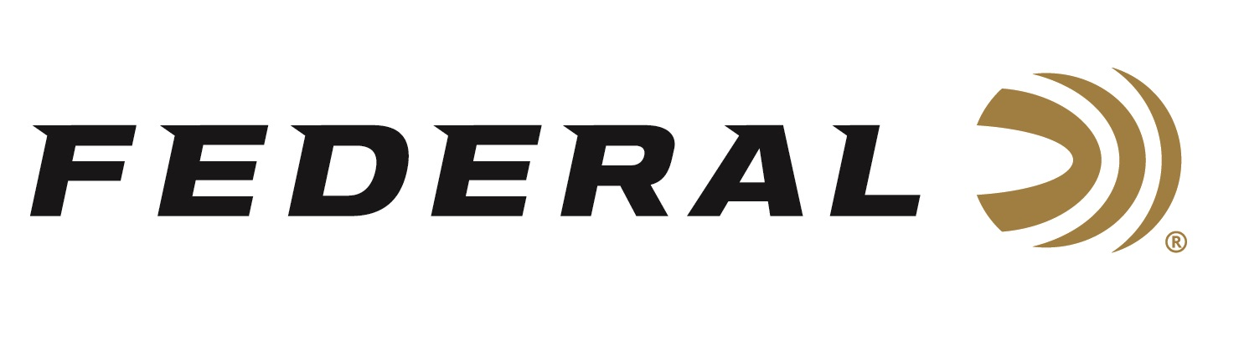

FOR IMMEDIATE RELEASE

Federal Offers Special Edition T-Shirt with all Profits to Support Ukraine

ANOKA, Minnesota – March 22, 2022 – In continuing support of Ukraine, Federal Ammunition will be selling a t-shirt benefiting crisis relief efforts in the war-torn country. This follows the announcement that Federal, along with sister ammunition brands CCI, Speer, and Remington, would be donating a total of one million rounds to the Ukraine armed forces.

“The war in Ukraine has displaced millions of citizens and exposed average people to the horrors of war,” said Jason Vanderbrink, president of Federal Ammunition, Remington, CCI, Speer. "Supporting the relief effort is a crucial element of the global response, and we are proud to do our part," continued Vanderbrink.

The t-shirt design, available at www.federalpremium.com, features the call out from the Ukrainian President needing ammunition to assist in their country’s defense.

The t-shirts are receiving a tremendous amount of support and are selling out quickly. If the desired shirt in six sizes from 3XL to small sell out, consumers can sign up to receive a notification of when the t-shirt has been restocked.

All profits from the sale of the limited-edition t-shirt will go to support the humanitarian relief efforts through Ukraine Crisis Relief Fund - GlobalGiving.

In addition to Federal’s efforts, Remington Ammunition will also be selling a similar design with all proceeds benefiting the displaced refugees.

Federal ammunition can be found at dealers nationwide or purchased online direct from Federal. For more information on all products from Federal or to shop online, visit www.federalpremium.com.

Press Release Contact: JJ Reich
Senior Communications Manager - Ammunition
E-mail: VistaPressroom@VistaOutdoor.com

About Federal Ammunition
Federal, headquartered in Anoka, MN, is a brand of Vista Outdoor Inc., an outdoor sports and recreation company. From humble beginnings nestled among the lakes and woods of Minnesota, Federal Ammunition has evolved into one of the world's largest producers of sporting ammunition. Beginning in 1922, founding president, Charles L. Horn, paved the way for our success. Today, Federal carries on Horn's vision for quality products and service with the next generation of outdoorsmen and women. We maintain our position as experts in the science of ammunition production. Every day we manufacture products to enhance our customers' shooting experience while partnering with the conservation organizations that protect and support our outdoor heritage. We offer thousands of options in our Federal Premium and Federal® lines-it's what makes us the most complete ammunition company in the business and provides our customers with a choice no matter their pursuit.

###

