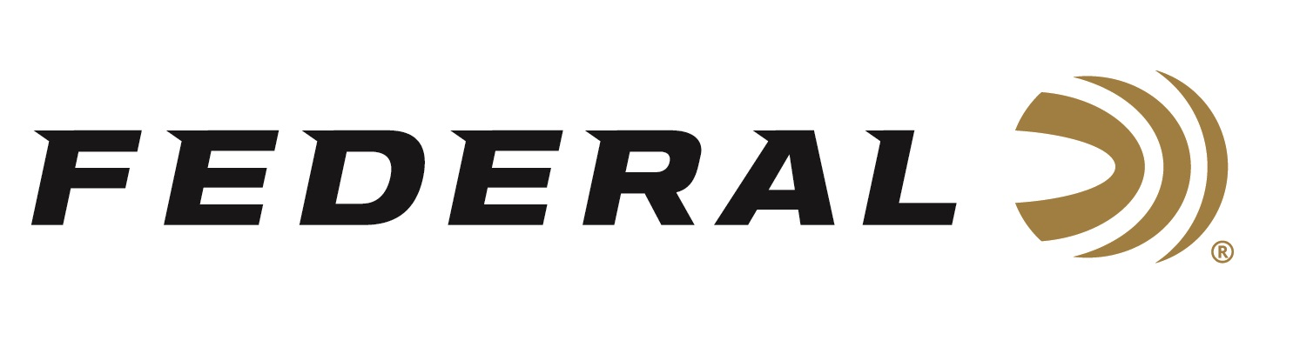

FOR IMMEDIATE RELEASE

Federal Wins 2022 Gold Award for Best Shotshells from Shooting Sports Retailer and Tactical Retailer

ANOKA, Minnesota – June 16, 2022 – Federal has received the 2022 Gold Award in the category of Shotshells by the readers of Shooting Sports Retailer and Tactical Retailer. This recognition showcases Federal Shotshells as the top choice for readers of these two distinguished publications.

Shooting Sports Retailer and Tactical Retailer sent ballots to their readers to find which shooting products were their top picks. Federal was voted as the Gold Award recipient by members of the shooting sports market representing independent retailers, gunsmiths, shooting range employees, and manufacturer reps. With voting coming from outdoor industry professionals, it showcases the quality and reliability of Federal shotshells.

“To be awarded the Gold recipient from both of these magazines is a huge honor,” said Federal Shotshell Product Director, Rick Stoeckel. “This shows that the hard-working people of the outdoor industry trust Federal shotshells as their top brand. This award continues to demonstrate why Federal Ammunition has been a trusted brand for 100 years.”

Federal shotshell ammunition covers a wide range of products for all types of shooters. For any shooting sports or tactical customer looking for shotshells for upland, waterfowl, sporting clays or self-defense, Federal Ammunition has a wide selection to fit the needs of shooters anywhere.

Federal ammunition can be found at dealers nationwide or purchased online direct from Federal. For more information on all products from Federal or to shop online, visit www.federalpremium.com.

Pictured: Jason Nash and Dan Compton from Federal Ammunition.

Press Release Contact: JJ Reich
Senior Manager – Press Relations
E-mail: VistaPressroom@VistaOutdoor.com
About Federal Ammunition
Federal, headquartered in Anoka, MN, is a brand of Vista Outdoor Inc., an outdoor sports and recreation company. From humble beginnings nestled among the lakes and woods of Minnesota, Federal Ammunition has evolved into one of the world's largest producers of sporting ammunition. Beginning in 1922, founding president, Charles L. Horn, paved the way for our success. Today, Federal carries on Horn's vision for quality products and service with the next generation of outdoorsmen and women. We maintain our position as experts in the science of ammunition production. Every day we manufacture products to enhance our customers' shooting experience while partnering with the conservation organizations that protect and support our outdoor heritage. We offer thousands of options in our Federal Premium and Federal® lines-it's what makes us the most complete ammunition company in the business and provides our customers with a choice no matter their pursuit.

