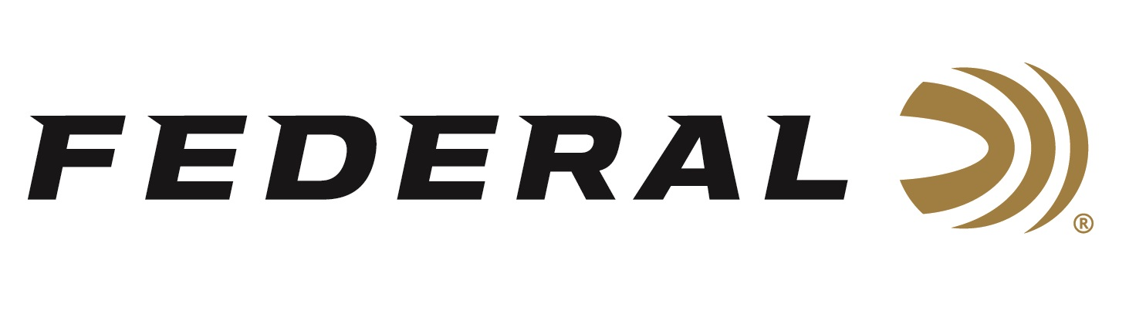

FOR IMMEDIATE RELEASE

Federal Wins Predator Xtreme 2022 Gold Award for Best Shotshells

ANOKA, Minnesota – January 20, 2022 – Federal has received the 2022 Gold Award in the category of Shotshells by the readers of Predator Xtreme. Hunters who read this magazine are extremely loyal to the products they use. These annual awards allow them to reveal what products they think are the absolute best. The award was given to Federal during the 2022 SHOT Show, January 18 at the Sands Expo Center in Las Vegas, Nevada.

Predator Xtreme polled its readership to find out their favorite gear; the products that really work. They then tallied the votes to determine the 2022 Readers' Choice Awards. The awards represent the best insider knowledge on products proven to work best for hunters nationwide. Reporting this knowledge helps their readers become better hunters and helps them smartly spend their hunting gear money wisely.

“Federal is proud to be crowned gold by readers of Predator Xtreme for the third year in a row. We know their readers know their stuff,” said Federal Shotshell Product Director Rick Stoeckel. “Federal has long been a fan favorite and continues to be the consistent brand predator hunters trust time and time again. We listen to our customers for what they need. Because of that, we are their top choice.”

Federal Premium Buckshot is engineered to provide precision and power. It uses copper-plated pellets to produce more downrange energy. Loads equipped with the FLITECONTROL wad system deliver the tightest patterns possible. Federal Power-Shot Buckshot delivers consistency in the field. The Triple Plus wad system provides better shot alignment and granulated plastic buffer keeps pellets uniform in shape for tight patterns. Federal offers a large variety of buckshot loads for hunting predators of all types.

Federal ammunition can be found at dealers nationwide or purchased online direct from Federal. For more information on all products from Federal or to shop online, visit www.federalpremium.com.

Press Release Contact: JJ Reich
Senior Manager – Press Relations
E-mail: VistaPressroom@VistaOutdoor.com
About Federal Ammunition
Federal, headquartered in Anoka, MN, is a brand of Vista Outdoor Inc., an outdoor sports and recreation company. From humble beginnings nestled among the lakes and woods of Minnesota, Federal Ammunition has evolved into one of the world's largest producers of sporting ammunition. Beginning in 1922, founding president, Charles L. Horn, paved the way for our success. Today, Federal carries on Horn's vision for quality products and service with the next generation of outdoorsmen and women. We maintain our position as experts in the science of ammunition production. Every day we manufacture products to enhance our customers' shooting experience while partnering with the conservation organizations that protect and support our outdoor heritage. We offer thousands of options in our Federal Premium and Federal® lines-it's what makes us the most complete ammunition company in the business and provides our customers with a choice no matter their pursuit.

