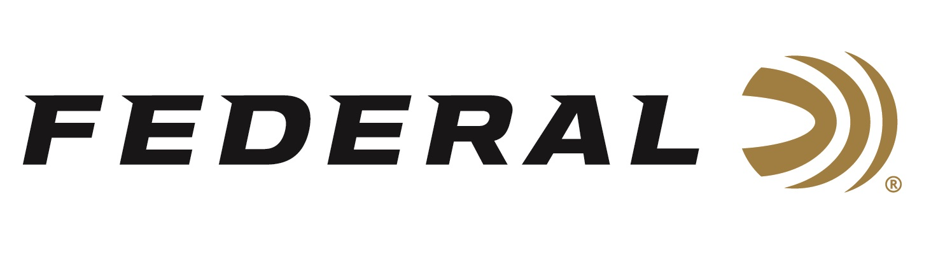

FOR IMMEDIATE RELEASE

Federal Ammunition Breaks Ground on a 100,000 Square-Foot
Raw Materials Warehouse Construction Project

ANOKA, Minnesota – August 31, 2022 – Federal Ammunition celebrated a warehouse expansion project with a groundbreaking ceremony on Tuesday, August 30. The multi-million-dollar, 100,000 square foot warehouse will be constructed in the eastern part of Federal’s property which sits within the city limits of Coon Rapids. Federal’s President Jason Vanderbrink, Tom Becker from Federal’s construction partner, The Opus Group, and the Mayor of Coon Rapids, Jerry Koch, gave short speeches and turned the dirt on the building site with golden shovels as part of the celebration event. The new facility is planned to be operational by early spring of 2023.

“This year, our company celebrated its 100-year anniversary, and this project continues the legacy of growth and investment in Anoka County,” said Jason Vanderbrink. “This is our first major building on our property within the city of Coon Rapids. Expanding operations across our grounds is very important as we become even more vertically integrated. This project will improve efficiency in our manufacturing process by storing, in close proximity and in one location, the raw materials needed to build ammunition for our loyal customers. I see this as the next big step in continuing our marketplace leadership and expanding our progress as the largest ammunition manufacturer that we are today.”

Federal’s Anoka facility currently encompasses 175 acres in Anoka County, Minnesota, with nearly 1 million square-feet of manufacturing and operations space. This property crosses the city lines of Anoka and Coon Rapids. The Anoka location has approximately 1,500 employees and the factory runs 24-7. The facility manufactures four types of ammunition products including shotshell, rifle, handgun, and rimfire ammunition, plus bullet and primers as reloading components. Federal’s factory is vertically integrated with tons of raw materials coming in and finished goods shipping out every day.

“Our mission is to empower Federal’s mission statement, which is ‘Build better ammunition in America to create community, power defense and conserve our heritage’, through the buildings we design and construct,” said Tom Becker. “We are also a Minnesota company, and we are proud to be Federal’s partner on this project. We know this new facility will help Federal by eliminating their current need of on-and-off-site material storage, ultimately allowing them to enhance their manufacturing capabilities on their factory floor and advance their overall mission.”

Federal ammunition can be found at dealers nationwide. For more information on all products from Federal or to shop online, visit www.federalpremium.com.

Press Release Contact: JJ Reich
Senior Manager – Press Relations
E-mail: VistaPressroom@VistaOutdoor.com

About Federal Ammunition
Federal, headquartered in Anoka, MN, is a brand of Vista Outdoor Inc., an outdoor sports and recreation company. From humble beginnings nestled among the lakes and woods of Minnesota, Federal Ammunition has evolved into one of the world's largest producers of sporting ammunition. Beginning in 1922, founding president, Charles L. Horn, paved the way for our success. Today, Federal carries on Horn's vision for quality products and service with the next generation of outdoorsmen and women. We maintain our position as experts in the science of ammunition production. Every day we manufacture products to enhance our customers' shooting experience while partnering with the conservation organizations that protect and support our outdoor heritage. We offer thousands of options in our Federal Premium and Federal® lines-it's what makes us the most complete ammunition company in the business and provides our customers with a choice no matter their pursuit.

