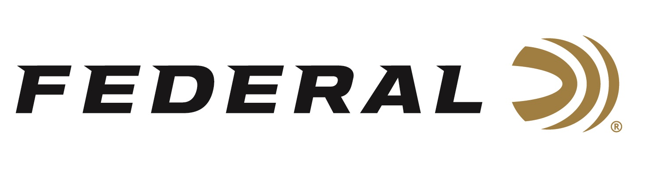

FOR IMMEDIATE RELEASE

Federal Ammunition Shooters Proudly Represented the U.S.A. at the IPRF World Championship

ANOKA, Minnesota – August 17, 2022 – Federal Ammunition professional shooters Buck Holly and Greg Bell represented the United States as part of Team USA at the International Precision Rifle Federation (IPRF) World Championship. The event was held on August 6-12, 2022 in Bitche, France. There were 250 shooters from 26 countries who participated in the shoot.

The IPRF was established to create an internationally recognized precision rifle competition. Throughout the 6-day shoot, Team USA participated in a variety of precision shooting events taking first place in every division and category other than the Factory Division.

“I’ve always said that precision rifle competitions here in the United States feature the best all-around rifle shooters in the world. It’s great to see an opportunity for American shooters to prove themselves against the world,” said Jason Spradling, Federal’s Manager of Shooting Sports Promotions/Field Training. “It’s a huge honor to have two of our Team Federal shooters invited to represent Team USA.”

Along with Team USA's overall success, Federal Shooters Holly and Bell placed high in their respective events individually. Buck Holly placed second in the Limited Division using Federal’s Gold Medal Match 308 Win loaded with 185-grain Berger Juggernaut bullets. Using the Federal Gold Medal primers, Greg Bell placed 5th in the Open Division with handloads.

“The weather conditions in France were challenging, to say the least,” said Federal Sponsored Shooter, Buck Holly. “Having great ammo allowed me to perform well despite the tough conditions.”

“I can’t adequately explain how much it means to me to have been allowed to represent my country at the IPRF World Championship,” said Federal Sponsored Shooter Greg Bell. “Overall, it was THE most fun I have had at a match in a long time.”

Federal ammunition can be found at dealers nationwide. For more information on all products from Federal or to shop online, visit www.federalpremium.com.

Press Release Contact: JJ Reich
Senior Manager – Press Relations
E-mail: VistaPressroom@VistaOutdoor.com

About Federal Ammunition
Federal, headquartered in Anoka, MN, is a brand of Vista Outdoor Inc., an outdoor sports and recreation company. From humble beginnings nestled among the lakes and woods of Minnesota, Federal Ammunition has evolved into one of the world's largest producers of sporting ammunition. Beginning in 1922, founding president, Charles L. Horn, paved the way for our success. Today, Federal carries on Horn's vision for quality products and service with the next generation of outdoorsmen and women. We maintain our position as experts in the science of ammunition production. Every day we manufacture products to enhance our customers' shooting experience while partnering with the conservation organizations that protect and support our outdoor heritage. We offer thousands of options in our Federal Premium and Federal® lines-it's what makes us the most complete ammunition company in the business and provides our customers with a choice no matter their pursuit.

