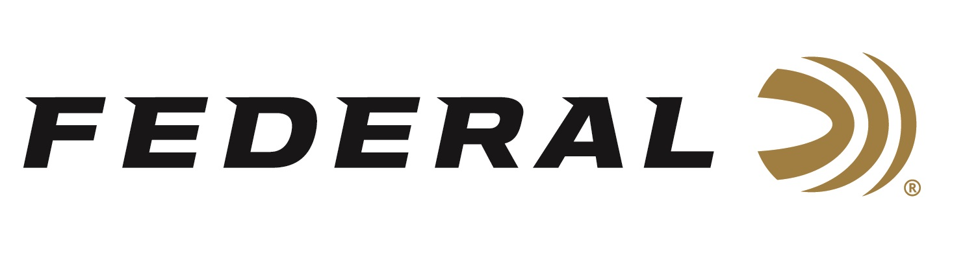

FOR IMMEDIATE RELEASE

Federal Premium Gold Medal Sierra MatchKing 6.5 Creedmoor Named Most Accurate by Outdoor Life

ANOKA, Minnesota – August 12, 2022 – After extensive testing by the editors of Outdoor Life, the Federal Gold Medal 6.5 Creedmoor, 140-grain Sierra MatchKing was named the Editors Choice for the most accurate load in 6.5 Creedmoor. The article outlining the testing and results was written by Outdoor Life Shooting Editor, John Snow.

During the testing, the Federal Gold Medal Sierra MatchKing was shot through 9 different 6.5 Creedmoor rifles. The ammunition performed above its competitors, with the smallest 10 five-shot groups measuring an average .501 in (1/2 MOA).

“The quality in design, craftsmanship, and components of Federal products is highly recognized once again by this acknowledgment from Outdoor Life,” said Jason Nash, Federal’s Vice President of Marketing. “The rigorous testing by the editors shows that the Federal Gold Medal 6.5 Creedmoor, 140-grain Sierra MatchKing is the go-to load for out-of-the-box accuracy for the 6.5 Creedmoor cartridge.”

Federal Gold Medal 6.5 Creedmoor 140-grain Sierra MatchKing is built for long-range accuracy. The load uses exclusive benchrest-quality Gold Medal primer design and the precision-built Sierra MatchKing bullet. The boat-tail hollow-point bullet is built with a uniform match jacket to ensure consistent long-range accuracy.

This product features, a uniform match bullet jacket to ensure consistent, long-range accuracy, reliable Federal brass, specially formulated propellant, and a Federal Premium Gold Medal primer. It’s sold in 20-count boxes. Learn more at: https://www.federalpremium.com/rifle/.

Federal ammunition can be found at dealers nationwide or purchased online direct from Federal. For more information on all products from Federal or to shop online, visit www.federalpremium.com.

Press Release Contact: JJ Reich
Senior Manager – Press Relations
E-mail: VistaPressroom@VistaOutdoor.com
About Federal Ammunition
Federal, headquartered in Anoka, MN, is a brand of Vista Outdoor Inc., an outdoor sports and recreation company. From humble beginnings nestled among the lakes and woods of Minnesota, Federal Ammunition has evolved into one of the world's largest producers of sporting ammunition. Beginning in 1922, founding president, Charles L. Horn, paved the way for our success. Today, Federal carries on Horn's vision for quality products and service with the next generation of outdoorsmen and women. We maintain our position as experts in the science of ammunition production. Every day we manufacture products to enhance our customers' shooting experience while partnering with the conservation organizations that protect and support our outdoor heritage. We offer thousands of options in our Federal Premium and Federal® lines-it's what makes us the most complete ammunition company in the business and provides our customers with a choice no matter their pursuit.

