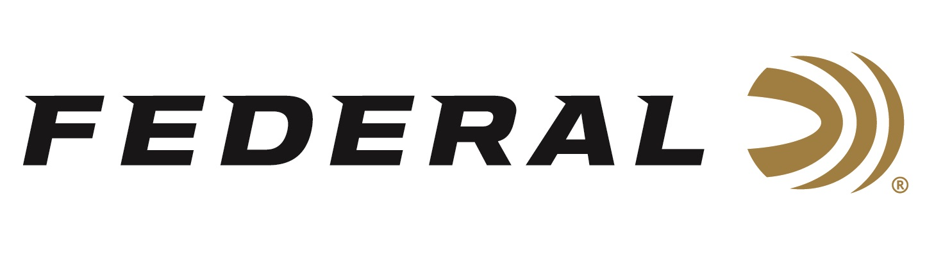

FOR IMMEDIATE RELEASE

Federal Recognized as Most Frequently Purchased
Rifle Ammunition Brand in Southwick Report

ANOKA, Minnesota – April 5, 2022 – Southwick Associates’ 2021 “Hunting & Shooting Participation and Equipment Purchases Consumer Tracking Study” named Federal Ammunition the top rifle ammunition brand in 2021. Southwick’s yearly survey compiled the feedback of over 11,000 hunters and recreational shooters.

“We are excited to see Federal Ammunition as the top choice for rifle ammunition,” said Federal Centerfire Rifle Product Director, Mike Holm. “Our commitment is to produce a top-quality product that hunters and shooters can rely on. This report shows the efforts of everyone at Federal is well received by rifle shooters.”

In the rifle ammunition purchase survey, Federal and its affiliate brands including dominated the category. All brands combined accounted for over 29% of total boxes purchased overall. With all of these different products and brands, rifle shooters are sure to find their perfect match for performance in the field or on the bench.

“Quality and performance continue to keep Federal Rifle ammunition at the top,” said Holm. “From the production line to everyone involved in the development and creation of Federal Ammunition products, we take immense pride in producing a line of rifle ammunition that continues to have a stellar reputation.”

Southwick’s in-depth resources illustrate shopping behaviors, such as where consumers buy, brand preferences, and amount spent. Learn more at www.southwickassociates.com.

Federal ammunition can be found at dealers nationwide or purchased online direct from Federal. For more information on all products from Federal or to shop online, visit www.federalpremium.com.

Press Release Contact: JJ Reich
Senior Manager – Press Relations
E-mail: VistaPressroom@VistaOutdoor.com

About Federal Ammunition
Federal, headquartered in Anoka, MN, is a brand of Vista Outdoor Inc., an outdoor sports and recreation company. From humble beginnings nestled among the lakes and woods of Minnesota, Federal Ammunition has evolved into one of the world's largest producers of sporting ammunition. Beginning in 1922, founding president, Charles L. Horn, paved the way for our success. Today, Federal carries on Horn's vision for quality products and service with the next generation of outdoorsmen and women. We maintain our position as experts in the science of ammunition production. Every day we manufacture products to enhance our customers' shooting experience while partnering with the conservation organizations that protect and support our outdoor heritage. We offer thousands of options in our Federal Premium and Federal® lines-it is what makes us the most complete ammunition company in the business and provides our customers with a choice no matter their pursuit.

