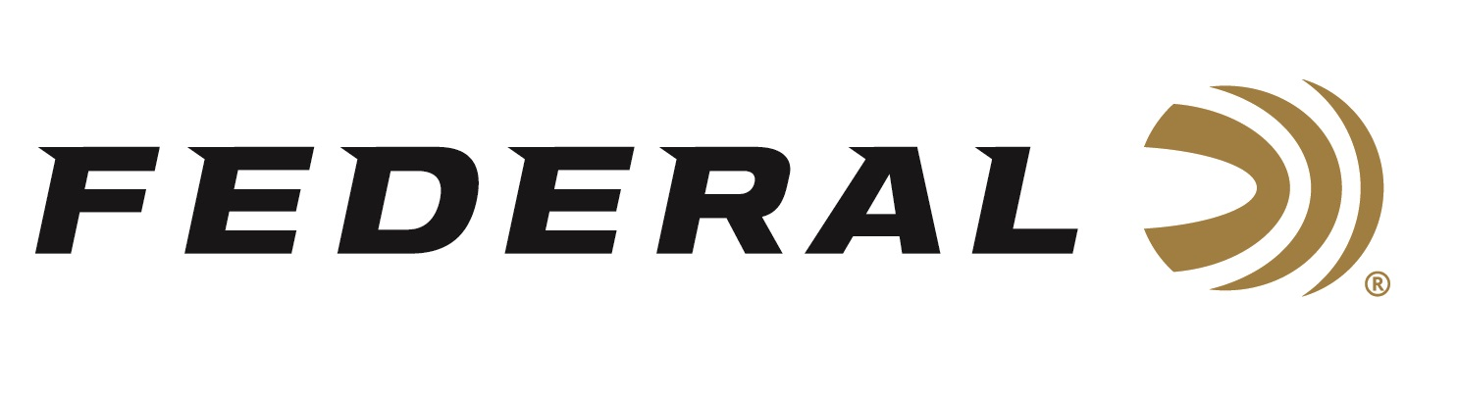

FOR IMMEDIATE RELEASE

Federal Recognized as Most Frequently Purchased Shotshell Ammunition Brand in Southwick Report

ANOKA, Minnesota – April 5, 2022 – Federal Ammunition leads the category of most frequently purchased shotgun ammunition according to the Southwick Associates’ 2021 “Hunting & Shooting Participation and Equipment Purchases Consumer Tracking Study.” Southwick’s yearly survey compiled the feedback of over 11,000 hunters and recreational shooters.

“The fact that Federal shotshell ammunition leads the category for most shotgun ammo purchased is a testament to the demanding work everyone at Federal puts into creating these products,” said Rick Stockel, Product Director for Federal Shotshell Ammunition. “This year’s survey showed 26.1% of shotshell ammo purchased was Federal. This is truly a team effort, and our company couldn’t be prouder.”

In the shotgun ammunition purchase survey, Federal and its affiliate brands boast category-wide success. All brands combined accounted for over 33% of boxes purchased. With this wide range of product choices, shotgun hunters and shooters can easily find a product to fit their needs from these brands.

“We want to continue to have Federal Ammunition be a company that fills all of your shotgun ammunition needs,” continued Stockel. “For those that enjoy cold mornings in the duck blind, to busting clays, and for home defense, Federal Ammunition’s quality and trusted performance is there to meet those needs.”

Southwick’s in-depth resources illustrate shopping behaviors, such as where consumers buy, brand preferences, and amount spent. Learn more at www.southwickassociates.com.

Federal ammunition can be found at dealers nationwide or purchased online direct from Federal. For more information on all products from Federal or to shop online, visit www.federalpremium.com.

Press Release Contact: JJ Reich
Senior Manager – Press Relations
E-mail: VistaPressroom@VistaOutdoor.com
About Federal Ammunition
Federal, headquartered in Anoka, MN, is a brand of Vista Outdoor Inc., an outdoor sports and recreation company. From humble beginnings nestled among the lakes and woods of Minnesota, Federal Ammunition has evolved into one of the world's largest producers of sporting ammunition. Beginning in 1922, founding president, Charles L. Horn, paved the way for our success. Today, Federal carries on Horn's vision for quality products and service with the next generation of outdoorsmen and women. We maintain our position as experts in the science of ammunition production. Every day we manufacture products to enhance our customers' shooting experience while partnering with the conservation organizations that protect and support our outdoor heritage. We offer thousands of options in our Federal Premium and Federal® lines-it is what makes us the most complete ammunition company in the business and provides our customers with a choice no matter their pursuit.

