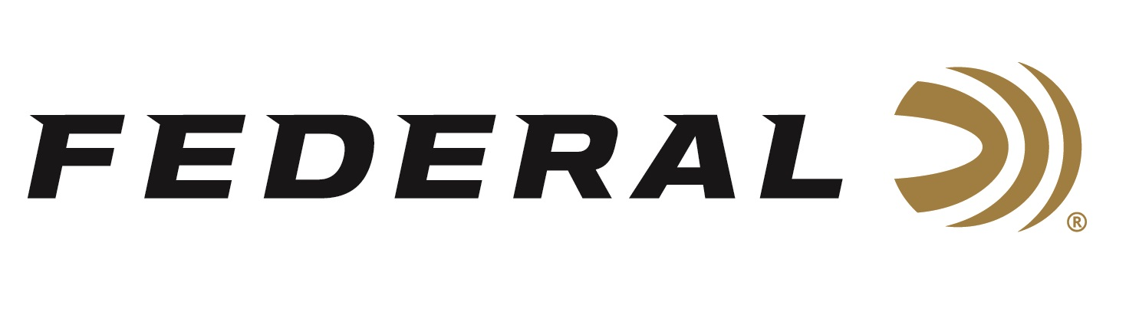

FOR IMMEDIATE RELEASE

Federal Sponsored Shooter Vincent Hancock Wins Big at Championship Skeet Match

ANOKA, Minnesota – August 12, 2022 – Federal Ammunition sponsored shooter Vincent Hancock adds to the list of recent events won by Federal sponsored shotgun shooters. 3-time Olympic Gold Medalist Vincent Hancock won the 2022 Skeet Nationals Championship. The shoot was held on August 6, 2022, at the John Anthony Halter Shooting Sports Center in Hillsdale, Michigan.

Using Federal Premium Gold Medal shotshells, Hancock scored 248/250 broken targets in the qualification rounds. During the Gold Medal Final, Hancock secured 59/60 to win the gold medal in a field of 46 shooters.

The win at the 2022 Skeet Nationals Championship adds to an already accomplished-filled 2022 shooting season for Hancock. At the 2022 ISSF World Cup in Baku Azerbaijan, Hancock won three gold medals in individual and team shooting events.

“2022 Skeet Nationals was a big success,” said Vincent Hancock. “It was a fun event that I was able to perform well at. The 2022 season has been one to remember. A big thank you to my sponsors including Federal Ammunition for being my partners and providing the gear needed to succeed.”

Federal ammunition can be found at dealers nationwide. For more information on all products from Federal or to shop online, visit www.federalpremium.com.

Press Release Contact: JJ Reich
Senior Manager – Press Relations
E-mail: VistaPressroom@VistaOutdoor.com

About Federal Ammunition
Federal, headquartered in Anoka, MN, is a brand of Vista Outdoor Inc., an outdoor sports and recreation company. From humble beginnings nestled among the lakes and woods of Minnesota, Federal Ammunition has evolved into one of the world's largest producers of sporting ammunition. Beginning in 1922, founding president, Charles L. Horn, paved the way for our success. Today, Federal carries on Horn's vision for quality products and service with the next generation of outdoorsmen and women. We maintain our position as experts in the science of ammunition production. Every day we manufacture products to enhance our customers' shooting experience while partnering with the conservation organizations that protect and support our outdoor heritage. We offer thousands of options in our Federal Premium and Federal® lines-it's what makes us the most complete ammunition company in the business and provides our customers with a choice no matter their pursuit.

