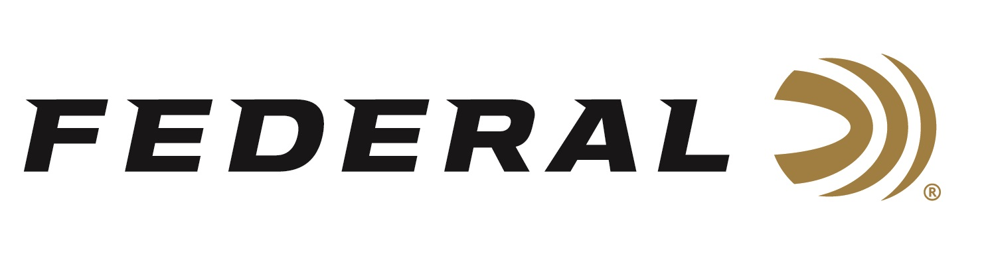

FOR IMMEDIATE RELEASE

Federal Ammunition Sponsored Shooter Vincent Hancock Wins Three Gold Medals at 2022 ISSF World Cup

ANOKA, Minnesota – June 17, 2022 – Federal Ammunition sponsored shooter and Olympic Gold Medalist, Vincent Hancock, wins three gold medals at the 2022 ISSF World Cup in Baku, Azerbaijan. Hancock continues to build upon his storied shooting career with these gold medals at the ISSF World Cup competition.

“Vincent performs at a high-level with professionalism time and time again,” said Jason Nash, Federal’s Vice President of Marketing. “We know that a talent of this level has to trust the best equipment available, and we are proud to have him as part of the Federal Ammunition shooting team family.”

The first gold medal for Hancock came in the Men’s Skeet competition with a victory over Nicolas LeJeune in the finals. Hancock’s second gold medal came in the Men’s Skeet Team event where the USA team of Hancock, Phillip Jungman and Adam McBee bested Greece in the finals.

Hancock and Federal Ammunition sponsored shooter, Austen Smith, joined together to win the Skeet Mixed Team event on the last day of the ISSF World Cup. The two Olympians defeated a German team in the gold medal match capping off a very successful three gold medal performance for Hancock at this ISSF World Cup event.

“It was great to see Vincent and Austen back in competition against a fierce competitive field of such skilled shooters, from all across the world,” continued Nash. “To be able to represent the USA and come away with three gold medals was a great accomplishment.”

Federal is also a large supporter of the Amateur Trap Association (ATA), National Skeet Shooters Association (NSSA), National Sporting Clays Association (NSCA), and many other national, regional, and state shooting sports organizations.

Federal ammunition can be found at dealers nationwide or purchased online direct from Federal. For more information on all products from Federal or to shop online, visit www.federalpremium.com.

Press Release Contact: JJ Reich
Senior Manager – Press Relations
E-mail: VistaPressroom@VistaOutdoor.com

About Federal Ammunition
Federal, headquartered in Anoka, MN, is a brand of Vista Outdoor Inc., an outdoor sports and recreation company. From humble beginnings nestled among the lakes and woods of Minnesota, Federal Ammunition has evolved into one of the world's largest producers of sporting ammunition. Beginning in 1922, founding president, Charles L. Horn, paved the way for our success. Today, Federal carries on Horn's vision for quality products and service with the next generation of outdoorsmen and women. We maintain our position as experts in the science of ammunition production. Every day we manufacture products to enhance our customers' shooting experience while partnering with the conservation organizations that protect and support our outdoor heritage. We offer thousands of options in our Federal Premium and Federal® lines-it's what makes us the most complete ammunition company in the business and provides our customers with a choice no matter their pursuit.

