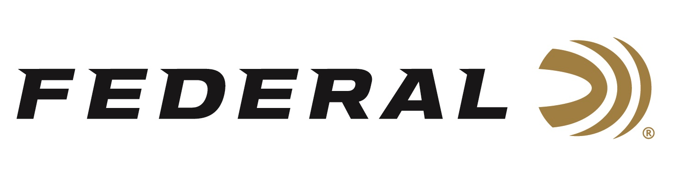

FOR IMMEDIATE RELEASE

Force X2 Shorty 00 Buckshot Joins the Federal Premium Personal Defense Shotshell Product Line

ANOKA, Minnesota – June 6, 2022 – Federal Ammunition adds the Force X2 Shorty Shotshell to the line of Premium Personal Defense Shotshells. The Force X2 Shorty is designed for use in firearms capable of cycling sub-length shotshells. This new 12-gauge 1 ¾-inch shotshell allows for higher magazine capacity with up to twice the wound channels over traditional buckshot pellets. This new product is currently shipping to dealers.

“Shotgun platforms are evolving to be able to cycle 1 ¾-inch shells reliably. The Mossberg 590S is a great example of that,” said Jesse Whiteside, Federal's Senior Director of Product Management. “When Mossberg demonstrated the new gun to us, we immediately saw the potential of the increased capacity and terminal effects of Shorty Force X2 load.”

The Force X2 Shorty packs a punch with six-pellet 00 copper plated segmenting buckshot. Each pellet is designed to split in half on impact. This allows the loads to have double the wound channels while reducing the risk of collateral damage from over penetration.

“The concept behind Force X2 is pretty straightforward. In a 6-pellet 00 FX2 Buck load you get 12 wound channels,” continued Whiteside. “And with the short size, you get more magazine capacity. It’s as simple as that.”

Joining a full line of proven Federal Premium Personal Defense Shotshells, the Force X2 Shorty carries the same quality and performance expected by users. When repeatability is needed, the Force X2 Shorty is designed with manageable recoil.

Part No. / Description / MSRP
PD129FX2 00 / 12 Ga FX2, 1 ¾I-inch, 00 Buckshot, 10-Count / $28.99

Federal Ammunition can be found at dealers nationwide or purchased online direct from Federal. For more information on all products from Federal or to shop online, visit www.federalpremium.com.

Press Release Contact: JJ Reich
Senior Manager – Press Relations
E-mail: VistaPressroom@VistaOutdoor.com

About Federal Ammunition
Federal, headquartered in Anoka, MN, is a brand of Vista Outdoor Inc., an outdoor sports and recreation company. From humble beginnings nestled among the lakes and woods of Minnesota, Federal Ammunition has evolved into one of the world's largest producers of sporting ammunition. Beginning in 1922, founding president, Charles L. Horn, paved the way for our success. Today, Federal carries on Horn's vision for quality products and service with the next generation of outdoorsmen and women. We maintain our position as experts in the science of ammunition production. Every day we manufacture products to enhance our customers' shooting experience while partnering with the conservation organizations that protect and support our outdoor heritage. We offer thousands of options in our Federal Premium and Federal® lines-it's what makes us the most complete ammunition company in the business and provides our customers with a choice no matter their pursuit.

