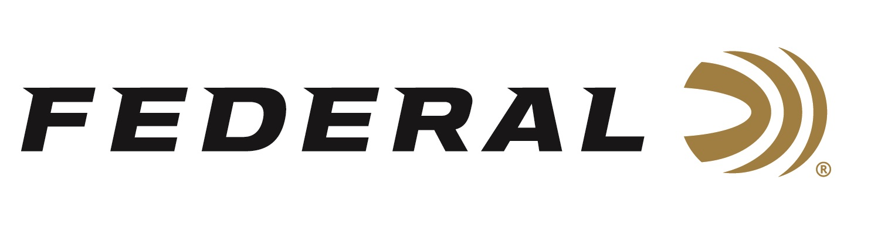

FOR IMMEDIATE RELEASE

On Target Magazine Honors Federal Premium Force X2 with Editors’ Choice Award

ANOKA, Minnesota – February 2, 2022 – On Target magazine recently recognized Federal’s Force X2 shotshell ammunition with an Editors’ Choice Award for best new ammunition for 2021, as part of the magazine’s annual awards program.

“These awards are reserved for the best-of-the-best new products which demonstrate outstanding technical achievement and/or represent an extraordinary value for the money,” said On Target Magazine Editor Ben Battles. “Given the advancements in bullet technology in the recent past, buckshot has largely remained unchanged over the last 100 years. Federal decided 2021 was the year buckshot would change forever and has released its new Force X2 Personal Defense 12-gauge 00 Buckshot load. The secret to this new technology is Federal’s all-new, high-performance Force X2 splitting buckshot. It’s a winner.”

Federal’s 12-gauge Force X2 load boasts a 9-pellet, 1-ounce, 00 buckshot payload leaving the muzzle at 1,245 feet-per-second (fps). Upon impact, nine buckshot pellets separate and break into up to 18 pellets, dumping more energy and doubling traditional wound channels to deliver the greatest terminal performance of any standard buckshot load. The pellets are copper-plated, and the payload is buffered. These features protect the pellets from deformation during the firing process, leading to more consistent patterns.

“We at Federal decided it was time to improve buckshot, so our expert engineers designed a load that would help in some personal defense situations. This award increases the validation of this product’s innovation,” said Federal’s Shotshell Product Director Rick Stoeckel. “We are honored to have On Target editors recognize Force X2 and are very encouraged by the tremendous response from consumers on this product.”

On Target is one of the leading publications in the shooting sports industry. Its staff tests and reviews guns, ammunition, and hunting products, and presents the results in a straightforward, no-nonsense format that provides all the information consumers need to make purchase decisions. The print version of On Target can be picked up free at any of the nearly 2,000 firearm and hunting product retailers nationwide that distribute the magazine.

Federal ammunition can be found at dealers nationwide or purchased online direct from Federal. For more information on all products from Federal or to shop online, visit www.federalpremium.com.

Press Release Contact: JJ Reich
Senior Communications Manager - Ammunition
E-mail: VistaPressroom@VistaOutdoor.com

About Federal Ammunition
Federal, headquartered in Anoka, MN, is a brand of Vista Outdoor Inc., an outdoor sports and recreation company. From humble beginnings nestled among the lakes and woods of Minnesota, Federal Ammunition has evolved into one of the world's largest producers of sporting ammunition. Beginning in 1922, founding president, Charles L. Horn, paved the way for our success. Today, Federal carries on Horn's vision for quality products and service with the next generation of outdoorsmen and women. We maintain our position as experts in the science of ammunition production. Every day we manufacture products to enhance our customers' shooting experience while partnering with the conservation organizations that protect and support our outdoor heritage. We offer thousands of options in our Federal Premium and Federal® lines-it's what makes us the most complete ammunition company in the business and provides our customers with a choice no matter their pursuit.

###

