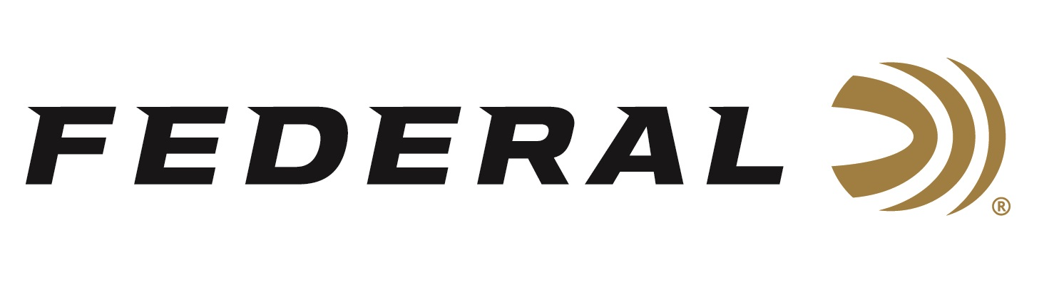

FOR IMMEDIATE RELEASE

Froelich Finishes First at the Minnesota TriGun Championship

ANOKA, Minnesota – June 15, 2022 – Team Federal congratulates brand ambassador Josh Froelich on winning 1st Overall and 1st Open Division titles at the 2022 Vortex JP Tri-Gun held at Forest Lake Sportsman’s Club in Minnesota, June 11-12. Federal Ammunition was a Platinum Sponsor for the event.

“This event is shotgun heavy, as most Minnesota events are, and had a focus on technical shooting skills. That meant small steel plates and challenging paper targets. A lot of movement and difficult shooting positions were the name of the game up here,” stated Froelich, a Minnesota native, who relied on Federal handgun, rifle, and shotshell ammunition to win big at this prestigious match. “Competition is always tight and many of the best in the country come up to Minnesota to compete. The Minnesota TriGun Championship is one of my favorite events of the year and I am super excited that I was able to secure the win here in 2022.”

Team Federal’s Tucker Schmidt took 3rd in the Open Division and 5th Overall. Varick Beise took 3rd in Tactical Optics Division and 6th Overall.

“This match had some great shooters in attendance, as always. Froelich did what Froelich does, and he cleaned house,” said Jason Spradling, Federal’s Shooting Sports Promotions Manager. “Tucker and Varick fought hard to claim third place finishes in each of their divisions. Federal congratulates all of these guys on their successes.”

“I was fortunate enough to pull a 3rd place finish in a stacked field of competitors,” said Schmidt. “I was running the Federal Gold Medal Match with 69-grain Sierra bullets in my rifle. They always provide handload-level quality, consistency, and they never disappoint. That’s why I choose Federal.”

“This match was very fun and challenging, with most of the stages involving running bay to bay or through the woods. The longer stages and sporty shots made this match one of my favorites,” said Beise. “The event organizers there put together a great match for all shooters. I am grateful for the good range officers, volunteers and sponsors that made it all possible.”

Federal ammunition can be found at dealers nationwide or purchased online direct. For more on Federal ammunition, visit www.federalpremium.com.

Press Release Contact: JJ Reich
Senior Manager – Press Relations
E-mail: VistaPressroom@VistaOutdoor.com

About Federal Ammunition
Federal, headquartered in Anoka, MN, is a brand of Vista Outdoor Inc., an outdoor sports and recreation company. From humble beginnings nestled among the lakes and woods of Minnesota, Federal Ammunition has evolved into one of the world's largest producers of sporting ammunition. Beginning in 1922, founding president, Charles L. Horn, paved the way for our success. Today, Federal carries on Horn's vision for quality products and service with the next generation of outdoorsmen and women. We maintain our position as experts in the science of ammunition production. Every day we manufacture products to enhance our customers' shooting experience while partnering with the conservation organizations that protect and support our outdoor heritage. We offer thousands of options in our Federal Premium and Federal® lines-it's what makes us the most complete ammunition company in the business and provides our customers with a choice no matter their pursuit.

