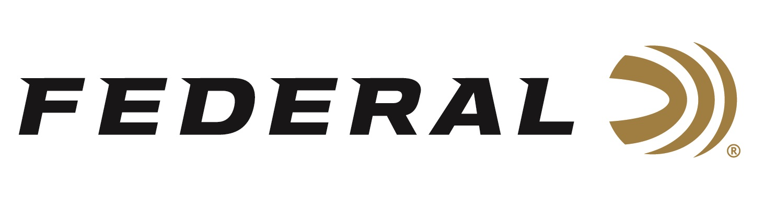

FOR IMMEDIATE RELEASE

Federal’s 30 Super Carry Cartridge Named ‘Ammo of the Year’ by Guns & Ammo Magazine

ANOKA, Minnesota – November 7, 2022 – Guns & Ammo magazine recently awarded Federal’s 30 Super Carry Handgun Ammunition as Ammo of the Year for 2022. The announcement was made in the December, 2022 issue of the publication. Released in 2022, the 30 Super Carry bridges a gap in self-defense loads, delivering a unique, compact, and ultra-effective option for everyday carry.

The article stated: “The 30 Super Carry is a forward-looking cartridge. The way the industry innovates is to push boundaries beyond what already exists. The introduction of the 30 Super Carry paves the way for the future development of new pistols that use modern manufacturing to optimize capacity, dimensions, ergonomics and weight."

To win the award of Ammo of the Year, the 30 Super Carry met the demands of being a reliable new to market product. The 30 Super Carry from Federal was tested rigorously for performance and judged on a point system of quality, design, and affordability. Testing was conducted by the editors and contributors of Guns & Ammo Magazine.

“Federal is very excited to have the 30 Super Carry named as Ammo of the Year,” said Federal Ammunition’s Senior Director of Engineering Drew Goodlin. “The 30 Super Carry has better terminal performance than a 380 Auto and as much muzzle energy as a 9mm Luger, all with a .312-inch projectile. Paired with Federal’s proven HST bullet, the 30 Super Carry can be used in a smaller firearm platform without compromising performance or carrying less rounds.”

The 30 Super Carry can hold 12 or more rounds in a magazine that is like the size of a 10-round 9mm Luger. The 30 Super Carry is offered by Federal with a 100-Grain HST bullet design and an American Eagle Full Metal Jacket option.

Read full article here: https://www.gunsandammo.com/editorial/guns-ammo-of-the-year-awards-2022/466003

For more information on all products and online services from Federal or to shop online, visit www.federalpremium.com.

Press Release Contact: JJ Reich
Senior Manager – Press Relations
E-mail: VistaPressroom@VistaOutdoor.com

About Federal Ammunition
Federal, headquartered in Anoka, MN, is a brand of Vista Outdoor Inc., an outdoor sports and recreation company. From humble beginnings nestled among the lakes and woods of Minnesota, Federal Ammunition has evolved into one of the world's largest producers of sporting ammunition. Beginning in 1922, founding president, Charles L. Horn, paved the way for our success. Today, Federal carries on Horn's vision for quality products and service with the next generation of outdoorsmen and women. We maintain our position as experts in the science of ammunition production. Every day we manufacture products to enhance our customers' shooting experience while partnering with the conservation organizations that protect and support our outdoor heritage. We offer thousands of options in our Federal Premium and Federal® lines-it's what makes us the most complete ammunition company in the business and provides our customers with a choice no matter their pursuit.

