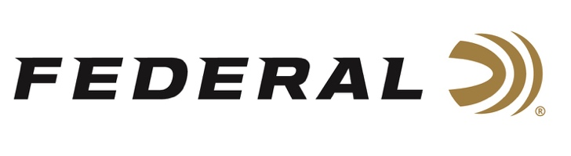

FOR IMMEDIATE RELEASE

Federal Sponsored Shooter Paul Giambrone III Collects Top Honors at Triple J Classic

ANOKA, Minnesota – March 23, 2022 – Team Federal congratulates Paul Giambrone III on winning the 20-gauge event at the Triple J Classic. The event was held at the National Shooting Complex in San Antonio, Texas, March 11-13, 2022.

“Weather started out rough for the event, but eventually cooperated over the weekend,” said Federal’s Shoot Promotions manager Mike Hampton, Sr. “It was great to see Team Federal shooters perform well in advance of a busy season. Federal had a great showing at the event, and we are very proud of how our sponsored shotgun sport shooters did at this shoot.”

Considered the spring kick-off event for the National Skeet Shooting Association, the event featured six event titles including 12-ga., 20-ga., 28-ga., .410, Doubles and HOA, and drew nearly three hundred shooters. Giambrone was using Federal Top Gun 20 Gauge No. 9 to win his 20 gauge title. For finishing 4th in the HOA, he used Top Gun 28 Gauge No. 9 and Top Gun 410 Bore No. 9 to accomplish this standing.

"Going into the shoot, I had to deal with several unknown factors due to using a new gun, tubes, and glasses, but my one reliable performance constant was Federal Ammunition. That kept me at ease as I competed," said Giambrone. "Friends and fellow competitors who watched commented they saw me 'get in the zone' during the shoot, and I am happy with how I finished. I thank my family, friends, sponsors and Federal Ammunition for the continued support.”

Top Gun loads deliver trusted performance specifically designed for excellence in all applications of clay target shooting. They push their payloads fast to shorten leads yet reduce felt recoil to allow for quicker follow-up shots. They feature hard, quality pellets for breaking more clays; consistent, reliable Federal primers; and unique wad column to produce consistent patterns. Loads are available in a wide variety of velocities, shot size and payload options for 12-, 20- and 28-guage, plus .410 bore.

Class winners receive a free entry into the 2023 Triple J Classic. The event calendar is busy for the NSSA over the next month as the ACUI, SW Grand and the World English Sporting Championships will be held at the National Shooting Complex. Keep tuned for more results from Federal sponsored shooters.

For more information on all products from Federal or to shop online, visit www.federalpremium.com.

Press Release Contact: JJ Reich
Senior Manager – Press Relations
E-mail: VistaPressroom@VistaOutdoor.com

About Federal Ammunition
Federal, headquartered in Anoka, MN, is a brand of Vista Outdoor Inc., an outdoor sports and recreation company. From humble beginnings nestled among the lakes and woods of Minnesota, Federal Ammunition has evolved into one of the world's largest producers of sporting ammunition. Beginning in 1922, founding president, Charles L. Horn, paved the way for our success. Today, Federal carries on Horn's vision for quality products and service with the next generation of outdoorsmen and women. We maintain our position as experts in the science of ammunition production. Every day we manufacture products to enhance our customers' shooting experience while partnering with the conservation organizations that protect and support our outdoor heritage. We offer thousands of options in our Federal Premium and Federal® lines-it's what makes us the most complete ammunition company in the business and provides our customers with a choice no matter their pursuit.

###

