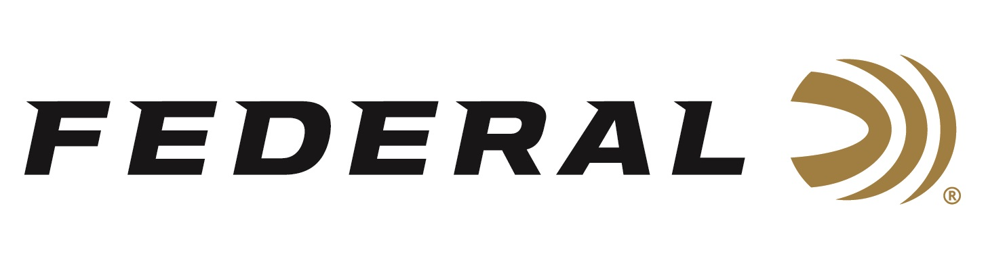

FOR IMMEDIATE RELEASE

New 30 Super Carry Added to Line of HST Ammunition from Federal

ANOKA, Minnesota – April 12, 2022 – Federal Ammunition proudly offers a 100-grain HST Jacketed Hollow Point (JHP) load to one of the biggest new handgun cartridge introductions in decades: the 30 Super Carry. The new 30 Super Carry cartridge bridges the largest performance gap in handgun self-defense ammunition. Check with your local ammo store for availability.

Penetrating performance and magazine capacity are major considerations when choosing a firearm platform for self-defense. Traditionally, users have had to choose between a smaller platform with reduced bullet performance or a larger platform to carry more rounds, while carrying a larger overall firearm. The 30 Super Carry has better terminal performance than a 380 and as much muzzle energy as a 9mm, all with a .312-inch projectile. Users will see performance similar to 9mm Luger with slightly less recoil and additional magazine capacity.

“We are excited to add this new HST Personal Defense handgun load to our overall lineup. A big advantage of the 30 Super Carry is that users get more performance from this offering without having to step up to a larger firearm,” said Jesse Whiteside, Federal’s Senior Director of Product Management. “The 30 Super Carry can hold 12 to 13 rounds in a magazine similar to the size of a 10-round 9mm Luger. Combine these performance features with Federals’ proven HST bullet, and this creates an excellent self-defense option.”

The Federal HST bullet design is matched with the 30 Super Carry for maximum performance. The specially engineered hollow point is designed for deep penetration and larger expansion. To fight against corrosion, the 30 Super Carry uses a nickel-plated case. This makes the HST Super Carry an ideal choice for personal defense scenarios.

Part No. / Description / MSRP
P30HST1S / 30 Super Carry, 100-grain HST JHP, 20-count / $36.99

For more information on all products from Federal or to shop online, visit www.federalpremium.com.

Press Release Contact: JJ Reich
Senior Manager – Press Relations
E-mail: VistaPressroom@VistaOutdoor.com
About Federal Ammunition
Federal, headquartered in Anoka, MN, is a brand of Vista Outdoor Inc., an outdoor sports and recreation company. From humble beginnings nestled among the lakes and woods of Minnesota, Federal Ammunition has evolved into one of the world's largest producers of sporting ammunition. Beginning in 1922, founding president, Charles L. Horn, paved the way for our success. Today, Federal carries on Horn's vision for quality products and service with the next generation of outdoorsmen and women. We maintain our position as experts in the science of ammunition production. Every day we manufacture products to enhance our customers' shooting experience while partnering with the conservation organizations that protect and support our outdoor heritage. We offer thousands of options in our Federal Premium and Federal® lines-it's what makes us the most complete ammunition company in the business and provides our customers with a choice no matter their pursuit.

