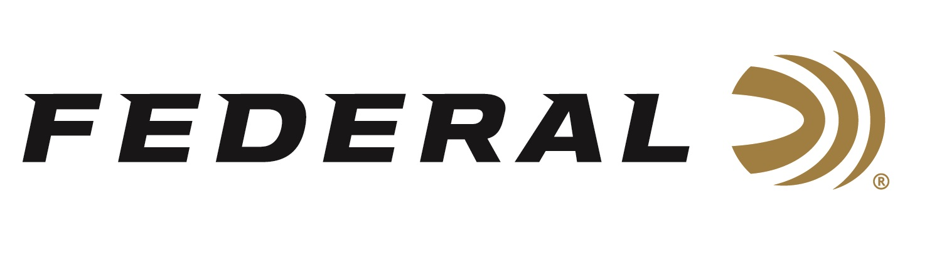

FOR IMMEDIATE RELEASE

New Federal Premium HEVI-Bismuth Shotshells Announced at the 2022 NRA Show

ANOKA, Minnesota – May 26, 2022 – Attendees of the 2022 NRA Annual Meetings & Exhibits will be the first to see the new line of Federal Premium HEVI-Bismuth shotshells. This line of shotshells lets hunters pursue both upland birds and waterfowl with a hard-hitting, lead-free option, and will be available in both 12- and 20-gauge variants.

Federal Premium HEVI-Bismuth along with other new products from Federal Ammunition will be on display in booth #2423, May 27-29, 2022, at the 2022 NRA show held at the George R. Brown Convention Center in Houston, Texas.

HEVI-Bismuth shot gives hunters the confidence of lead performance in a non-lead pellet. For years Bismuth has set the standard for performance for waterfowl hunters. HEVI-Bismuth boasts a heavy-hitting payload of 9.6g/cc density pellets and is 22 percent denser than steel.

“Hunters wanting a non-lead shotshell option with increased performance will want to add HEVI-Bismuth to their hunting bag or vest this hunting season,” said Dan Compton, Federal’s Shotshell Product Manager. “We sourced the shot from our partners at HEVI-Shot and added Federal’s rear-deploying FLITECONTROL FLEX wad for even greater downrange performance.”

Available in three 20-gauge and six 12-gauge variants, the Federal Premium HEVI-Bismuth will fit the shotshell needs of waterfowl and upland hunters. The loads have higher pellet counts than comparable performing steel shot loads. HEVI-Bismuth pellets are not only softer than steel and tungsten but can safely be used in both modern and classic shotguns.

“HEVI-Bismuth will be a great addition to the already wide range of shotshell products Federal offers,” continued Compton. “With bismuth also being safe to use in classic shotguns, hunters can take their favorite heirloom shotgun back into the field to hunt upland and waterfowl without worrying about damaging their barrels.”

Federal ammunition can be found at dealers nationwide or purchased online direct from Federal. For more information on all products from Federal or to shop online, visit www.federalpremium.com.
Press Release Contact: JJ Reich
Senior Manager – Press Relations
E-mail: VistaPressroom@VistaOutdoor.com

About Federal Ammunition
Federal, headquartered in Anoka, MN, is a brand of Vista Outdoor Inc., an outdoor sports and recreation company. From humble beginnings nestled among the lakes and woods of Minnesota, Federal Ammunition has evolved into one of the world's largest producers of sporting ammunition. Beginning in 1922, founding president, Charles L. Horn, paved the way for our success. Today, Federal carries on Horn's vision for quality products and service with the next generation of outdoorsmen and women. We maintain our position as experts in the science of ammunition production. Every day we manufacture products to enhance our customers' shooting experience while partnering with the conservation organizations that protect and support our outdoor heritage. We offer thousands of options in our Federal Premium and Federal® lines-it's what makes us the most complete ammunition company in the business and provides our customers with a choice no matter their pursuit.

