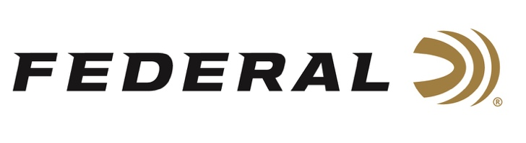

FOR IMMEDIATE RELEASE

Team Federal Shooters Win Medals at the 2022 ISSF President’s Cup

ANOKA, Minnesota – December 9, 2022 – Team Federal shooters Derrick Mein, Caitlin Connor and Vincent Hancock continued the US streak of Trap and Skeet medals at the 2022 ISSF President’s Cup in Cairo, Egypt, November 28 through December 4.

World Champion Shooter Caitlin Connor earned a gold medal after beating Martina Bartolomei of Italy in the gold medal match. She was ranked fourth in the world for Women’s Skeet prior to the event. Connor also took home the Golden Target Award at this event.

Champion Shooter, 2021 US Olympic Team Member, and top ranked Men’s Trap shooter Derrick Mein earned a silver medal at the event after facing Josip Glasnovic of Croatia in the gold medal match.

Vincent Hancock, the number one ranked Men’s Skeet shooter, earned bronze at the event. Hancock is a 3-time Olympic Gold Medalist. He also recently won the 2022 Skeet Nationals Championship.

“We are extremely proud of the stellar performance from these three brand ambassadors at this prestigious, worldwide event,” said Federal Ammunition Vice President of Marketing Jason Nash. “Their accomplishments reflect Federal’s dedication to its quality products and to the shooting sports. We look forward to more podium success from them and all the sponsored shooters on Team Federal.”

For more information on Gold Medal and Top Gun target loads that offer the competitive edge, visit www.federalpremium.com.

Press Release Contact: JJ Reich
Senior Manager – Press Relations
E-mail: VistaPressroom@VistaOutdoor.com

About Federal Ammunition
Federal, headquartered in Anoka, MN, is a brand of Vista Outdoor Inc., an outdoor sports and recreation company. From humble beginnings nestled among the lakes and woods of Minnesota, Federal Ammunition has evolved into one of the world's largest producers of sporting ammunition. Beginning in 1922, founding president, Charles L. Horn, paved the way for our success. Today, Federal carries on Horn's vision for quality products and service with the next generation of outdoorsmen and women. We maintain our position as experts in the science of ammunition production. Every day we manufacture products to enhance our customers' shooting experience while partnering with the conservation organizations that protect and support our outdoor heritage. We offer thousands of options in our Federal Premium and Federal® lines-it's what makes us the most complete ammunition company in the business and provides our customers with a choice no matter their pursuit.

###

