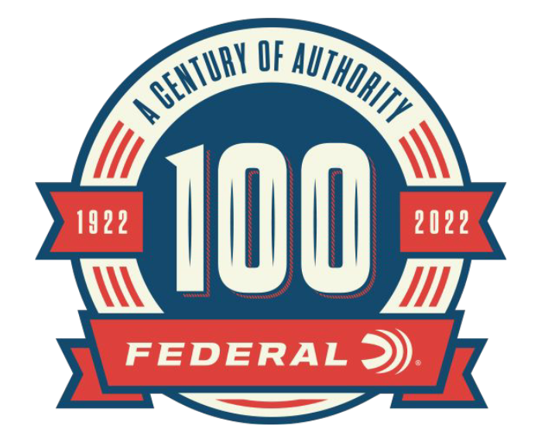

FOR IMMEDIATE RELEASE

Federal Ammunition’s 100-Year Anniversary Recognized by IWA

ANOKA, Minnesota – March 8, 2022 – At the 2022 IWA Classic in Nürnberg, Germany, Federal Ammunition was recognized by the convention for the upcoming 100th Anniversary of the company. Dave Leis and Peter Gillette of Federal Ammunition accepted a plaque in recognition of Federal’s 100th anniversary from the IWA exhibit management.

The IWA Outdoor Classics is a leading international trade fair for hunting, shooting sports, equipment for outdoor activities, and civilian and official security applications. At the 2022 IWA gathering, 856 exhibitors from 53 countries along with 19,500 attendees participated in the return of the event since it was last held in 2019. Federal Ammunition was proud to be one of the returning exhibitors to showcase the new product offerings for 2022.

“I would like to thank IWA and their exhibit management for recognizing Federal’s 100th anniversary at the recent IWA convention,” said Jason Vanderbrink, Federal Ammunition President. “2022 marks the 100-year anniversary of Federal Ammunition and this award will be a part of all the other milestones as we celebrate the rich history of our company.”
Federal Ammunition announced several new product offerings for 2022. Product launch highlights include: HST and American Eagle in 30 Super Carry, High Over All 12-gauge target loads, Force X2 Shorty shotshells, HammerDown in 35 Rem. and 444 Marlin, Top Gun with Paper Wad 12-gauge target loads, Punch 44 S&W Special, and HST Personal Defense in 357 Magnum and 327 Magnum.
The 2023 IWA Outdoor Classics will take place March 2-5 in Nürnberg, Germany. For more information on the IWA, visit www.iwa.info/en.

For more information on all products and online services from Federal or to shop online, visit www.federalpremium.com.

Press Release Contact: JJ Reich
Senior Manager – Press Relations
E-mail: VistaPressroom@VistaOutdoor.com

About Federal Ammunition
Federal, headquartered in Anoka, MN, is a brand of Vista Outdoor Inc., an outdoor sports and recreation company. From humble beginnings nestled among the lakes and woods of Minnesota, Federal Ammunition has evolved into one of the world's largest producers of sporting ammunition. Beginning in 1922, founding president, Charles L. Horn, paved the way for our success. Today, Federal carries on Horn's vision for quality products and service with the next generation of outdoorsmen and women. We maintain our position as experts in the science of ammunition production. Every day we manufacture products to enhance our customers' shooting experience while partnering with the conservation organizations that protect and support our outdoor heritage. We offer thousands of options in our Federal Premium and Federal® lines-it's what makes us the most complete ammunition company in the business and provides our customers with a choice no matter their pursuit.

