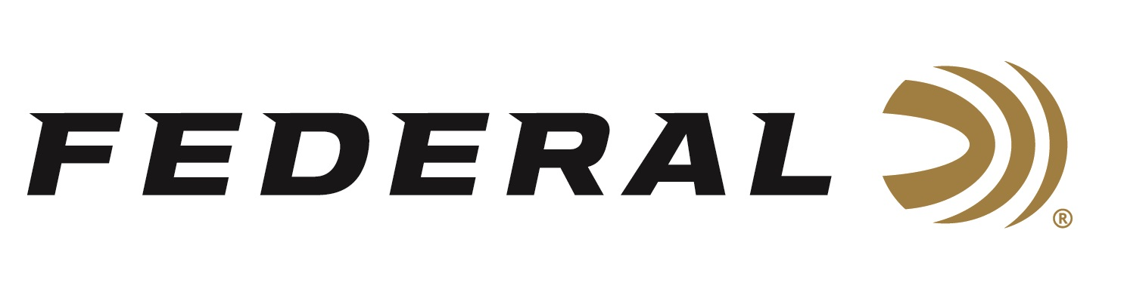

FOR IMMEDIATE RELEASE

Protection from Poachers on “It’s Federal Season” Podcast

ANOKA, Minnesota – October 13, 2022 – On this episode of the “It’s Federal Season” podcast, Nathan Edmondson, CEO of ECO Defense Group, joins the Federal team on location from Africa where he and his dedicated team continue the fight against the poaching of endangered wildlife.

Edmondson talks passionately about ECO Defense’s mission and the consultation and training work his team provides when working with local wildlife rangers. Edmondson describes the perils they and the local protectors face protecting endangered species like the rhino from human predators who have no conscience or fear.

In the Tech Talk segment, Sr. Director of New Product Development sits down with VP of Marketing Jason Nash to continue the Africa theme on the best bullets for plains game as well as dangerous game. The two discuss the optimal bullet weights depending on species as well as shot placement and the importance of studying anatomy as there are differences between North America’s Whitetail and the antelope species in Africa like Gemsbok, Kudu, or Springbok.

Episode #40 “Protection from Poachers”
https://www.federalpremium.com/this-is-federal/podcast/

For this episode, besides listening on the Federal Premium website or Talk North podcast network, you can also subscribe to Federal Ammunition’s YouTube channel (https://www.youtube.com/user/federalpremiumammo) and tune in for the discussion.

Federal Ammunition can be found at dealers nationwide or purchased online direct from Federal. For more information on all products from Federal or to shop online, visit www.federalpremium.com.

Press Release Contact: JJ Reich
Senior Manager – Press Relations
E-mail: VistaPressroom@VistaOutdoor.com

About Federal Ammunition
Federal, headquartered in Anoka, MN, is a brand of Vista Outdoor Inc., an outdoor sports and recreation company. From humble beginnings nestled among the lakes and woods of Minnesota, Federal Ammunition has evolved into one of the world's largest producers of sporting ammunition. Beginning in 1922, founding president, Charles L. Horn, paved the way for our success. Today, Federal carries on Horn's vision for quality products and service with the next generation of outdoorsmen and women. We maintain our position as experts in the science of ammunition production. Every day we manufacture products to enhance our customers' shooting experience while partnering with the conservation organizations that protect and support our outdoor heritage. We offer thousands of options in our Federal Premium and Federal® lines-it's what makes us the most complete ammunition company in the business and provides our customers with a choice no matter their pursuit.

