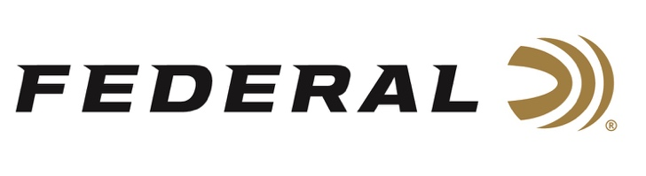

FOR IMMEDIATE RELEASE

Federal Ambassador Julie Golob Takes Gold and Silver at the 2022 Bianchi Cup

ANOKA, Minnesota – June 2, 2022 – Federal Ammunition is proud to congratulate legendary shooter, hunter, author, mother, and U.S. Army veteran Julie Golob on an excellent performance at the 2022 Bianchi Cup. Competitors from throughout the United States and worldwide attended the event, which is the Action Pistol National Championships and International Tournament, held at Green Valley Rifle & Pistol Club near Columbia, Missouri, May 25-27, 2022. Golob took home the Women’s Team Gold Medal and was the Women’s Silver Medalist. She placed 20th Overall in the Open Division.

“After a challenging 2 years of contending with COVID-19, this sport is building back up to pre-pandemic attendance, which is great to see,” said Golob. “The event consisted of four courses of fire: Practical, Barricades, Falling Plates, and Moving Target. The match tests extreme accuracy and speed. Unlike many other action shooting sports, Bianchi is unique in that there is a perfect score. It allows you to track your progress and test yourself against the best shooters in the world.”

“We at Federal congratulate Julie on her recent wins in Missouri,” said Federal Vice President of Marketing Jason Nash. “Julie and Federal have been partners for many years. She has done excellent work for us, promoting our brand and products. Especially this year with her efforts in helping us produce our ‘It’s Federal Season’ podcast. We thank her for all she does for us, on and off match stages.”

“I rely on Federal Premium components and use a custom load tuned for my Open Division action pistol that starts with high quality Federal brass and incredibly reliable Federal primers,” Golob said. “Their products build confidence in my performance.”

Federal Ammunition can be found at dealers nationwide or purchased online direct from Federal. For more information on all products from Federal or to shop online, visit www.federalpremium.com.

Press Release Contact: JJ Reich
Senior Manager – Press Relations
E-mail: VistaPressroom@VistaOutdoor.com
About Federal Ammunition
Federal, headquartered in Anoka, MN, is a brand of Vista Outdoor Inc., an outdoor sports and recreation company. From humble beginnings nestled among the lakes and woods of Minnesota, Federal Ammunition has evolved into one of the world's largest producers of sporting ammunition. Beginning in 1922, founding president, Charles L. Horn, paved the way for our success. Today, Federal carries on Horn's vision for quality products and service with the next generation of outdoorsmen and women. We maintain our position as experts in the science of ammunition production. Every day we manufacture products to enhance our customers' shooting experience while partnering with the conservation organizations that protect and support our outdoor heritage. We offer thousands of options in our Federal Premium and Federal® lines-it's what makes us the most complete ammunition company in the business and provides our customers with a choice no matter their pursuit.

###

