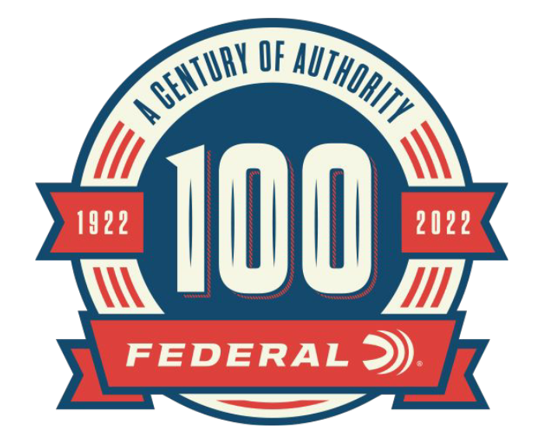

FOR IMMEDIATE RELEASE

New Historical Articles Added to Federal’s Website:
Trophy Bonded Bullets and BB Tubes

ANOKA, Minnesota – July 25, 2022 – As part of the 100-year anniversary celebration, Federal Ammunition is featuring monthly online content celebrating Federal’s rich history. The month of July highlights Federal’s Trophy Bonded product development and the production of air rifle shot. Content can be found on the 100-year anniversary website: https://www.federalpremium.com/this-is-federal/a-century-of-authority/.

Like many of the products developed by Federal Ammunition, the Trophy Bonded bullet was created to fit a need. The article “The Climb To The Top” follows the story of entrepreneur Jack Carter to develop a better penetrating expanding bullet for big game hunting. The article lays out the evolution of the Trophy Bonded Bear Claw to the Trophy Bonded Tip, and Federal’s Flagship hunting bullet, the Terminal Ascent.

“Using Federal products in real-world hunting situations has continued to push the company to create new products,” said Jason Nash, Federal Ammunition Vice President of Marketing. “The descendant products of the great Trophy Bonded Bear Claw continue to be our top hunting bullets as thousands of hunters trust them to work in the field.”

In 1933 American Ball moved manufacturing of steel BBs for air rifles to the Federal Anoka, Minnesota plant. The article “The Unlikely Start” details the proud history Federal had in making BBs.

“The history of Federal making BBs for air rifle shot is something that shouldn’t be forgotten,” said Nash. “One of Federal’s founding influential partners, Charles L. Horn was able to successfully demonstrate that steel BBs didn’t damage airgun barrels. The manufacturing of BBs was a big success factor in the early years of the company.”

Each month through the end of 2022, Federal Ammunition will be uploading additional content focused on the rich history of this American ammunition company. In addition to the monthly online content, Federal Ammunition has released a 244-page book preserving the company’s history. Federal Ammunition: The First Hundred Years can be found online at: https://www.federalpremium.com/merchandise/education/.

For more information on all products and online services from Federal or to shop for ammunition direct online, visit www.federalpremium.com.

Press Release Contact: JJ Reich
Senior Manager – Press Relations
E-mail: VistaPressroom@VistaOutdoor.com

About Federal Ammunition
Federal, headquartered in Anoka, MN, is a brand of Vista Outdoor Inc., an outdoor sports and recreation company. From humble beginnings nestled among the lakes and woods of Minnesota, Federal Ammunition has evolved into one of the world's largest producers of sporting ammunition. Beginning in 1922, founding president, Charles L. Horn, paved the way for our success. Today, Federal carries on Horn's vision for quality products and service with the next generation of outdoorsmen and women. We maintain our position as experts in the science of ammunition production. Every day we manufacture products to enhance our customers' shooting experience while partnering with the conservation organizations that protect and support our outdoor heritage. We offer thousands of options in our Federal Premium and Federal® lines-it's what makes us the most complete ammunition company in the business and provides our customers with a choice no matter their pursuit.

