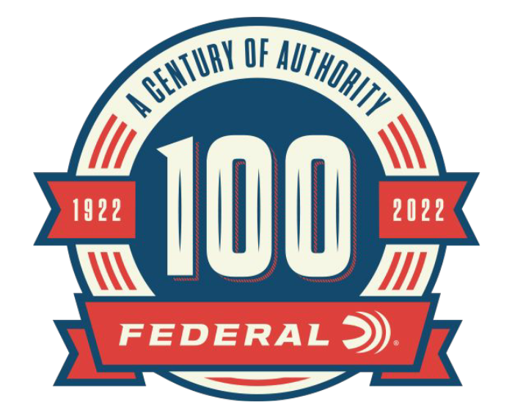

FOR IMMEDIATE RELEASE

New Historical Articles Added to the 100-Year Celebration Federal Ammunition Website

ANOKA, Minnesota – July 5, 2022 – As part of the 100-year anniversary celebration, Federal Ammunition is featuring monthly online content celebrating Federal’s rich history. The month of June highlighted Federal’s role in supplying war-time ammunition and conservation-focused advertising. These new articles can be found on the 100-year anniversary website: https://www.federalpremium.com/this-is-federal/a-century-of-authority/.

In times of war and peace, Federal Ammunition has supplied the men and women of the United States Armed Forces and allied countries with products that they can rely on. The article “Serving the Nation’s Warfighters” follows the history of Federal Ammunition first supplying 1.4 million mortar ignition cartridges to the British Purchasing Commission before the start of WWII to Vietnam and current military ammunition needs.

“One of the accomplishments we are most proud of at Federal is to be able to supply the U.S. and allied countries with reliable ammunition in times of peace and conflict,” said Jason Nash, Federal Ammunition Vice President of Marketing. “Over the years Federal has been able to tailor products to fit the scenarios of various conflicts for generations.”

In the 1930s, Federal Ammunition created a series of advertisements to tackle common misconceptions in wildlife conservation. In the article “Supporting Conservation with Advertisements” Federal Ammunition took the lead to inform and correct misinformation on a wide range of conservation issues from shooting owls and hawks to releasing feral cats, and extinguishing campfires.

“At Federal Ammunition we are outdoorsman and conservationists,” said Nash. “In the early years of our company history, Federal took the lead to correct thinking and practices that were harmful to wildlife and to help usher in a new understanding when it came to wildlife management.”

Each month through the end of 2022, Federal Ammunition will be uploading additional content focused on the rich history of this American ammunition company.

In addition to the monthly online content, Federal Ammunition has released a 244-page book preserving the company’s history. Federal Ammunition: The First Hundred Years can be found online at: https://www.federalpremium.com/merchandise/education/1001683.html.

For more information on all products and online services from Federal or to shop online, visit www.federalpremium.com.

Press Release Contact: JJ Reich
Senior Manager – Press Relations
E-mail: VistaPressroom@VistaOutdoor.com

About Federal Ammunition
Federal, headquartered in Anoka, MN, is a brand of Vista Outdoor Inc., an outdoor sports and recreation company. From humble beginnings nestled among the lakes and woods of Minnesota, Federal Ammunition has evolved into one of the world's largest producers of sporting ammunition. Beginning in 1922, founding president, Charles L. Horn, paved the way for our success. Today, Federal carries on Horn's vision for quality products and service with the next generation of outdoorsmen and women. We maintain our position as experts in the science of ammunition production. Every day we manufacture products to enhance our customers' shooting experience while partnering with the conservation organizations that protect and support our outdoor heritage. We offer thousands of options in our Federal Premium and Federal® lines-it's what makes us the most complete ammunition company in the business and provides our customers with a choice no matter their pursuit.

