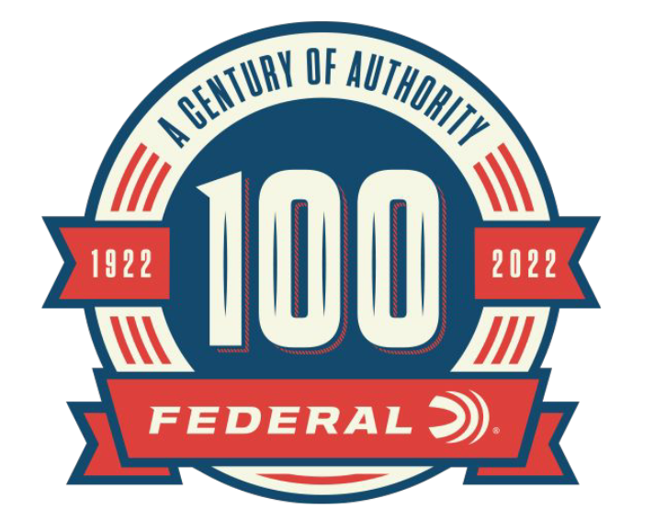

FOR IMMEDIATE RELEASE

100-Year Celebration Content Added to Federal Ammunition Website

ANOKA, Minnesota – May 31, 2022 – As part of the 100-year anniversary celebration, Federal Ammunition is featuring monthly online content celebrating Federal’s rich history. The month of May highlighted Federal’s founding personalities and the different private label names of Federal Ammunition. Content can be found on the 100-year anniversary website, www.federalpremium.com.

Since its beginning, the history of Federal Ammunition is filled with near-misses, what-ifs, and critical decisions. The article, “Federal’s Founding Personalities” chronicles the founders of the company to those that stepped in at what seemed like just the right time to lead the company forward.

“Federal Ammunition has a wide range of personalities and leaders that came at integral parts of the history of the company,” said Jason Nash, Federal Ammunition Vice President of Marketing. “The vision, work ethic, and business decisions made decades ago not only lead to the rich history of the company, but also the continued success of Federal Ammunition.”

The article “Federal Under Another Name” chronicles the different labels that Federal Ammunition was made under. At the beginning of the 20th century, users could acquire firearms and ammunition at a variety of retailers from hardware stores, barbers, doctors, grocery stores, and catalog dealers like Sears, Roebuck & Co. While most of these dealers sold ammunition under the Federal name, many dealers preferred a private label approach provided by Federal.

“In 1927 Federal Ammunition started providing private-branded ammunition to customers like Sears,” said Nash. “The ability to meet the needs of our dealers and customers is something we still pride ourselves on.”

Each month through the end of 2022, Federal Ammunition will be uploading additional content focused on the rich history of this American ammunition company. In addition to the monthly online content, Federal Ammunition has released a 244-page book preserving the company’s history. Federal Ammunition: The First Hundred Years can be found online at www.federalpremium.com.

For more information on all products and online services from Federal or to shop online, visit www.federalpremium.com.

Press Release Contact: JJ Reich
Senior Manager – Press Relations
E-mail: VistaPressroom@VistaOutdoor.com

About Federal Ammunition
Federal, headquartered in Anoka, MN, is a brand of Vista Outdoor Inc., an outdoor sports and recreation company. From humble beginnings nestled among the lakes and woods of Minnesota, Federal Ammunition has evolved into one of the world's largest producers of sporting ammunition. Beginning in 1922, founding president, Charles L. Horn, paved the way for our success. Today, Federal carries on Horn's vision for quality products and service with the next generation of outdoorsmen and women. We maintain our position as experts in the science of ammunition production. Every day we manufacture products to enhance our customers' shooting experience while partnering with the conservation organizations that protect and support our outdoor heritage. We offer thousands of options in our Federal Premium and Federal® lines-it's what makes us the most complete ammunition company in the business and provides our customers with a choice no matter their pursuit.

