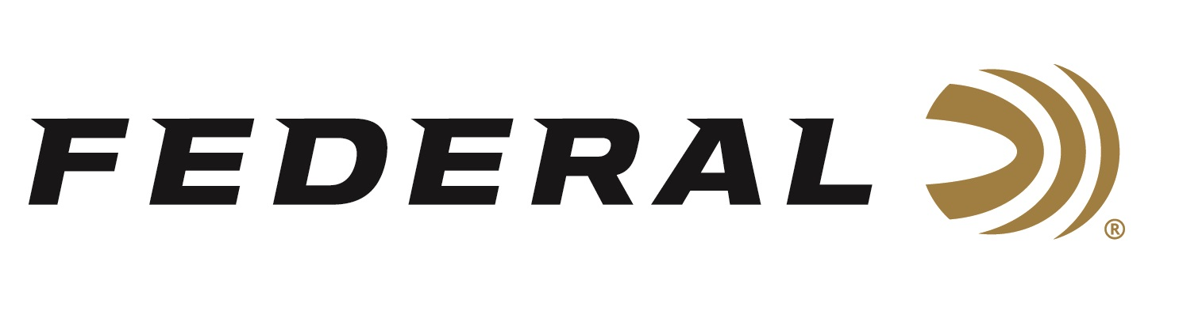

FOR IMMEDIATE RELEASE

Federal Sponsored Shooter Derrick Mein Wins 2022 Trap National Championship

ANOKA, Minnesota – July 28, 2022 – Team Federal congratulates Derrick Mein on his recent victory at the 2022 Trap National Championships held at the Halter Shooting Sports Education Center near Hillsdale, Michigan. For the second year in a row, Mein claimed the Men’s Open Event over some stiff competition from members of the U.S. Army’s Marksmanship Unit and Federal and Olympic teammate Brian Burrows.

“I performed very well,” said Federal sponsored shooter Derrick Mein. “With this win, I will be representing the USA at the ISSF World Shotgun Championships in Croatia this September, and I’m excited again to represent USA Shooting at a world competition.”

Mein bested runner-up Will Hinton and third place finisher Glenn Eller to punch his ticket to Osijek, Croatia September 20 through October 11, 2022. Mein got to the finals with a qualifying score of 243 out of 250 and broke 46 of 50 targets in the final.

“This was the first competition I shot Federal’s High Over All 24-gram product in competition and the results speak for themselves,” stated Mein.

The newest competition target load from Federal, High Over All, features the new Podium wad for improved patterns and hard, high antimony lead pellets that reduces deformation and delivers more downrange energy ensuring a trail of broken targets.

Federal ammunition can be found at dealers nationwide or purchased direct online. For more on Federal ammunition, visit www.federalpremium.com.

Press Release Contact: JJ Reich
Senior Manager – Press Relations
E-mail: VistaPressroom@VistaOutdoor.com

About Federal Ammunition
Federal, headquartered in Anoka, MN, is a brand of Vista Outdoor Inc., an outdoor sports and recreation company. From humble beginnings nestled among the lakes and woods of Minnesota, Federal Ammunition has evolved into one of the world's largest producers of sporting ammunition. Beginning in 1922, founding president, Charles L. Horn, paved the way for our success. Today, Federal carries on Horn's vision for quality products and service with the next generation of outdoorsmen and women. We maintain our position as experts in the science of ammunition production. Every day we manufacture products to enhance our customers' shooting experience while partnering with the conservation organizations that protect and support our outdoor heritage. We offer thousands of options in our Federal Premium and Federal® lines-it's what makes us the most complete ammunition company in the business and provides our customers with a choice no matter their pursuit.

