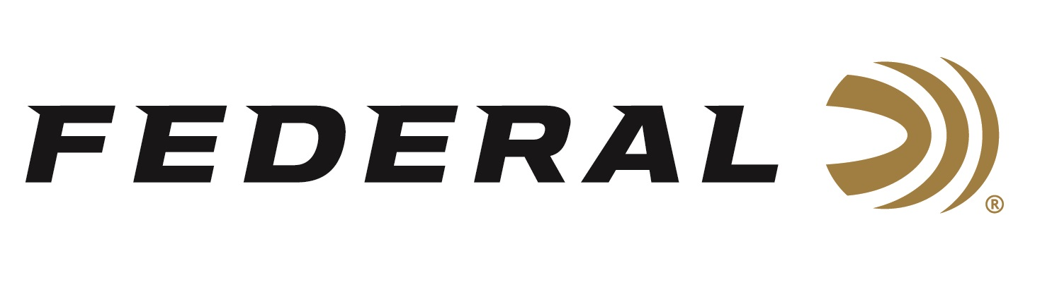
FOR IMMEDIATE RELEASE

Team Federal Shines at Superstition Mountain Mystery 3-Gun Match

ANOKA, Minnesota – March 25, 2022 – Team Federal had an excellent showing at the 26th Annual Superstition Mountain Mystery 3-Gun Match held at Rio Salado Sportsman's Club in Mesa, Arizona. This large event brings together the nation’s top 3-Gun shooters and is the longest running 3-Gun match in the country.

“This is a prestigious match, highly regarded in the shooting-competition community for innovative stage design and being well-run," said Federal Shooting Sports Promotions Manager Jason Spradling. "Our Team Federal shooters do a fantastic job representing our brand wherever they go. It's great to see them perform well in such a high-profile, challenging match. A special congratulations go out to Alysia Burrows for her category win."

Match results highlights includes Alysia Burrows (Utah) who won Top Lady in the Stealth 2-gun Division, and new team member Varick Beise (Minnesota) who received Top Junior honors in the Tactical 3-Gun Division, while also finishing 4th out of 85 shooters in that division and 15th overall out of 373 shooters.

“I was excited to start the 2022 season with a bang at this event in beautiful Mesa Arizona. This match is known for attracting some of the best around, and it’s always a privilege to shoot alongside them,” said Burrows. “What really gave me my edge this weekend was the 150-grain, 9mm Federal Syntech rounds. This load has low recoil, but also has strong power to knock down all the large heavy steel. And in a match like this, the long range can make or break your game. Federal Premium 69-grain Gold Medal .223 Rem. Sierra Match King rounds are so incredibly consistent. It’s so invigorating hearing those rounds ring on steel with every shot, even out at 300 yards and beyond. It is comforting knowing that when I do my part, Federal’s products will never let me down.”

Federal ammunition can be found at dealers nationwide or purchased online direct from Federal. For more information on all products from Federal or to shop online, visit www.federalpremium.com.

Press Release Contact: JJ Reich
Senior Manager – Press Relations
E-mail: VistaPressroom@VistaOutdoor.com

About Federal Ammunition
Federal, headquartered in Anoka, MN, is a brand of Vista Outdoor Inc., an outdoor sports and recreation company. From humble beginnings nestled among the lakes and woods of Minnesota, Federal Ammunition has evolved into one of the world's largest producers of sporting ammunition. Beginning in 1922, founding president, Charles L. Horn, paved the way for our success. Today, Federal carries on Horn's vision for quality products and service with the next generation of outdoorsmen and women. We maintain our position as experts in the science of ammunition production. Every day we manufacture products to enhance our customers' shooting experience while partnering with the conservation organizations that protect and support our outdoor heritage. We offer thousands of options in our Federal Premium and Federal® lines-it's what makes us the most complete ammunition company in the business and provides our customers with a choice no matter their pursuit.

