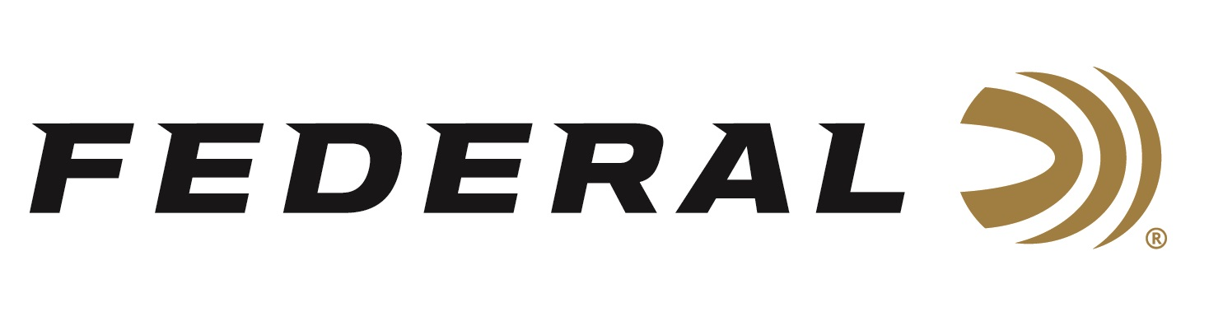

FOR IMMEDIATE RELEASE

Federal Ammunition Proud to Sponsor NWTF’s 2022 Convention and Sport Show for 39th Year

ANOKA, Minnesota – February 24, 2022 – Federal Ammunition recently hosted its annual Conservation Breakfast at the National Wild Turkey Federation’s (NWTF) 46th Annual Convention and Sport Show, held February 16-20, 2022 in Nashville, Tennessee. Federal Premium Ammunition was also a Gobbler Sponsor of the event.

“We’re proud to be celebrating 100 years of continuous operation this year. As we’ve gone through our archives to prepare for our official birthday this April 27th, we’ve been reminded again of how important conservation is to the history of Federal and our entire industry,” said Jason Nash, Vice President of Marketing. “Since 1984 the National Wild Turkey Federation has been one of our great program partners. The organization and its dedicated staff, members and volunteers have been instrumental in benefitting game and habitat for future generations to enjoy.”

Federal Ammunition and the National Wild Turkey Federation have been working hand in hand for decades. The company has participated at every NWTF convention and has hosted the Conservation Breakfast for 39 years. Federal Ammunition is one of the five longest-running sponsors and the only licensed ammunition partner of the NWTF.

“We appreciate everything NWTF members do to grow our sport and pass along this great heritage,” continued Nash. “Our copper-plated Grand Slam, 3rd Degree and Heavyweight TSS loads are all a priority for us as we continue to share a portion of the proceeds from the sale of those products with the NWTF. We thank NWTF for their longstanding partnership with us and we look forward to another 100 years of improving habitat and growing the sport we all love.”

With turkey populations in good shape throughout much of the country, hunters anticipate a memorable 2022 season. Now they can go afield knowing Federal’s new Premium turkey loads will not only deliver consistent, devastating performance, but also help turkeys themselves through their partnership with the NWTF.

For more information on all products from Federal or to shop online, visit www.federalpremium.com.

Press Release Contact: JJ Reich
Senior Manager – Press Relations
E-mail: VistaPressroom@VistaOutdoor.com

About Federal Ammunition
Federal, headquartered in Anoka, MN, is a brand of Vista Outdoor Inc., an outdoor sports and recreation company. From humble beginnings nestled among the lakes and woods of Minnesota, Federal Ammunition has evolved into one of the world's largest producers of sporting ammunition. Beginning in 1922, founding president, Charles L. Horn, paved the way for our success. Today, Federal carries on Horn's vision for quality products and service with the next generation of outdoorsmen and women. We maintain our position as experts in the science of ammunition production. Every day we manufacture products to enhance our customers' shooting experience while partnering with the conservation organizations that protect and support our outdoor heritage. We offer thousands of options in our Federal Premium and Federal® lines-it's what makes us the most complete ammunition company in the business and provides our customers with a choice no matter their pursuit.

