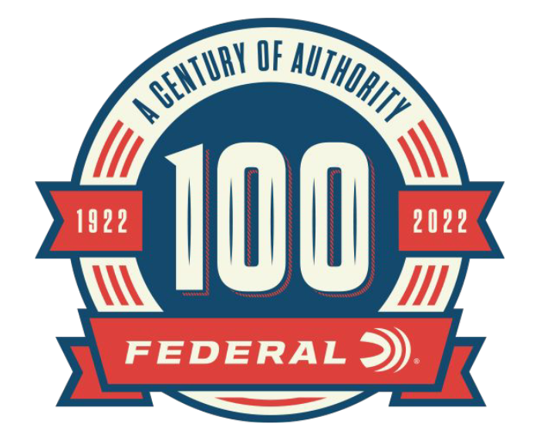

FOR IMMEDIATE RELEASE

New 100th Anniversary Content Added to the Federal Ammunition Website: Dr. Frederickson and Premium Ammo Lineup

ANOKA, Minnesota – November 28, 2022 – As part of the 100-year anniversary celebration, Federal Ammunition is featuring monthly online content celebrating Federal’s rich history. The month of November showcased the Premium ammunition product line and the honorary company historian, Doc Fred. Content can be found on the 100-year anniversary website: A Century Of Authority (federalpremium.com).

The life and history of the Federal company historian are documented in the article “Federal’s Doc Fred”. Dr. David Frederickson M.D. or known as “Doc Fred” was never a paid employee of Federal Ammunition but since the late 1960s was a collector of Federal Ammunition packaging and won display awards at ammunition collector shows.

“Without Doc, many parts of Federal’s history would be lost to time,” said Jason Nash, Federal Ammunition Vice President of Marketing. “Doc was an extremely passionate collector of Federal Ammunition and built relationships with company executives and employees. Thanks to his collection we have been able to better document any past product packaging. Generations to come can still enjoy his collections in museums and at the Federal factory buildings.”

The article “Federal Premium Product Line” follows the journey of Federal Ammunition providing hunters and shooters with the finest rifle ammunition. Federal combines the best casings, primers, bullets, plated shot and cleanest burning powder to produce the premium line of ammunition. From 22 LR to shotshells up to the 500 Nitro Express, the line of Federal Premium ammunition covers a wide range of uses.

“The Federal Premium product line has been trusted by hunters and shooters since the 1970s,” said Nash. “Hunters and shooters need the best possible tools to help them in the field and Federal Premium loads fit that need.”

Each month through the end of 2022, Federal Ammunition will be uploading additional content focused on the rich history of this American ammunition company. In addition to the monthly online content, Federal Ammunition has released a 244-page book preserving the company’s history. Federal Ammunition: The First Hundred Years can be found online at: Buy Federal The First 100 Years for USD 59.99 | Federal Ammunition (federalpremium.com).

For more information on all products and online services from Federal or to shop online, visit www.federalpremium.com.

Press Release Contact: JJ Reich
Senior Manager – Press Relations
E-mail: VistaPressroom@VistaOutdoor.com

About Federal Ammunition
Federal, headquartered in Anoka, MN, is a brand of Vista Outdoor Inc., an outdoor sports and recreation company. From humble beginnings nestled among the lakes and woods of Minnesota, Federal Ammunition has evolved into one of the world's largest producers of sporting ammunition. Beginning in 1922, founding president, Charles L. Horn, paved the way for our success. Today, Federal carries on Horn's vision for quality products and service with the next generation of outdoorsmen and women. We maintain our position as experts in the science of ammunition production. Every day we manufacture products to enhance our customers' shooting experience while partnering with the conservation organizations that protect and support our outdoor heritage. We offer thousands of options in our Federal Premium and Federal® lines-it's what makes us the most complete ammunition company in the business and provides our customers with a choice no matter their pursuit.

