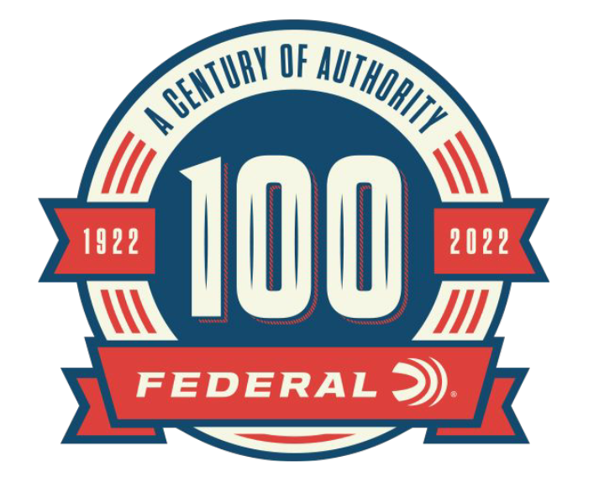

FOR IMMEDIATE RELEASE

New Content Added to Federal’s 100-Year Celebration Website: Crushing Clays and Transforming Rifle Ammunition

ANOKA, Minnesota – October 28, 2022 – As part of the 100-year anniversary celebration, Federal Ammunition is featuring monthly online content celebrating Federal’s rich history. Recent new article posts highlighted Federal’s shotshell target loads and Federal’s high-quality rifle ammunition. Content can be found on the 100-year anniversary micro website: A Century Of Authority (federalpremium.com).

Chronicling the history of Federal’s target shotshell line, “Crushing Clays Since The Early Days” describes what has made Federal loads a top choice for target shooters. In 1964 Federal introduced the Champion Target load setting the standard for competitive shooters. Federal target loads are known for consistent patterns and reliable performance and remain a top choice for competitive shooters.

“From backyard clay shoots to the Grand American and the Olympics, Federal target loads have set the standard in these competitions,” said Jason Nash, Federal Ammunition Vice President of Marketing. “When you consider the wide range of competitions that Federal Ammunition has helped shooters be successful in for decades, it’s another accomplishment in our company’s rich history.”

World War II propelled Federal ammunition to produce centerfire rifle ammunition. “Federal Transforms Rifle Ammunition” details the journey of Federal Rifle Ammunition production from WWII to ammunition rounds in which hunters, target shooters, and law enforcement have come to trust and use. As part of the continued advancement in the highest quality commercial loads available, Federal opened the Federal Custom Shop. A dedicated team of veteran, expert engineers, working at a state-of-the-art loading bench, hand-assemble the most precise ammunition with the best projectiles possible for almost 30 different centerfire rifle cartridges.

“Since 1963, Federal Ammunition has been producing centerfire rifle ammunition in a wide range of calibers and bullet designs,” said Nash. “Over the years we have been able to make advancements in bullet design and performance to fit popular rifle calibers. Quality and performance are a must in everything we produce and the advancements in our products proves that.”

Each month through the end of 2022, Federal Ammunition will be uploading additional content focused on the rich history of this American ammunition company. In addition to the monthly online content, Federal Ammunition has released a 244-page book preserving the company’s history. Federal Ammunition: The First Hundred Years can be found online at: Buy Federal The First 100 Years for USD 59.99 | Federal Ammunition (federalpremium.com)

For more information on all products and online services from Federal or to shop online, visit www.federalpremium.com.

Press Release Contact: JJ Reich
Senior Manager – Press Relations
E-mail: VistaPressroom@VistaOutdoor.com

About Federal Ammunition
Federal, headquartered in Anoka, MN, is a brand of Vista Outdoor Inc., an outdoor sports and recreation company. From humble beginnings nestled among the lakes and woods of Minnesota, Federal Ammunition has evolved into one of the world's largest producers of sporting ammunition. Beginning in 1922, founding president, Charles L. Horn, paved the way for our success. Today, Federal carries on Horn's vision for quality products and service with the next generation of outdoorsmen and women. We maintain our position as experts in the science of ammunition production. Every day we manufacture products to enhance our customers' shooting experience while partnering with the conservation organizations that protect and support our outdoor heritage. We offer thousands of options in our Federal Premium and Federal® lines-it's what makes us the most complete ammunition company in the business and provides our customers with a choice no matter their pursuit.

