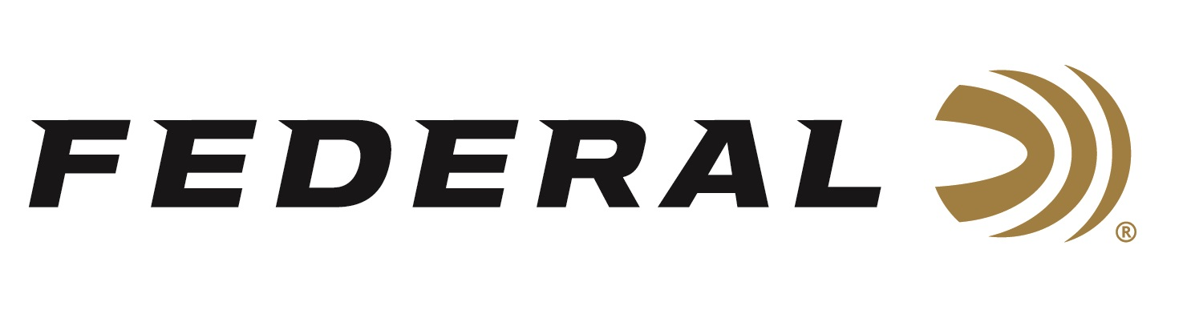

FOR IMMEDIATE RELEASE

Federal Ammunition Introduces New 22 WMR Punch Personal Defense at NRA Show

ANOKA, Minnesota – May 26, 2022 – Expanding on the line of personal defense ammo for rimfire platforms, Federal Ammunition is unveiling its new 22 WMR load at the 2022 NRA Annual Meetings & Exhibits. Punch 22 WMR is propelled at extreme velocities and engineered to minimize expansion to hit critical penetration depths even through short-barrel handguns.

The new 22 WMR along with other new products from Federal Ammunition will be on display in booth #2423, May 27-29, 2022, at the 2022 NRA show held at the George R. Brown Convention Center in Houston, Texas.

“After the launch of the Punch 22 LR we saw the great response to that round and wanted to expand the options,” said Federal’s Rimfire Product Director, Rick Stoeckel, “The Punch 22 WMR continues to allow rimfire users to have effective performance but now in the magnum cartridge.”

Punch 22 WMR expands on the line of Federal Premium Punch Personal Defense options, now in the 22 Win. Mag. Rimfire cartridge. The Punch 22 WMR features a 45-grain nickel-plated lead-core bullet. This bullet is designed for maximum penetration needed in personal defense scenarios. This new load has gone through rigorous testing for reliability and function. The case of the Punch 22 WMR is nickel-plated for easier extraction and corrosion resistance.

“The success of the bullet designed for the Punch 22 LR easily transferred to the WMR,” continued Stoeckel. “The larger 45 grain bullet and extreme velocities in the Punch 22 WMR allows this to be a great round for popular 22 WMR revolvers.”

Federal ammunition can be found at dealers nationwide or purchased online direct from Federal. For more information on all products from Federal or to shop online, visit www.federalpremium.com.

Press Release Contact: JJ Reich
Senior Manager – Press Relations
E-mail: VistaPressroom@VistaOutdoor.com
About Federal Ammunition
Federal, headquartered in Anoka, MN, is a brand of Vista Outdoor Inc., an outdoor sports and recreation company. From humble beginnings nestled among the lakes and woods of Minnesota, Federal Ammunition has evolved into one of the world's largest producers of sporting ammunition. Beginning in 1922, founding president, Charles L. Horn, paved the way for our success. Today, Federal carries on Horn's vision for quality products and service with the next generation of outdoorsmen and women. We maintain our position as experts in the science of ammunition production. Every day we manufacture products to enhance our customers' shooting experience while partnering with the conservation organizations that protect and support our outdoor heritage. We offer thousands of options in our Federal Premium and Federal® lines-it's what makes us the most complete ammunition company in the business and provides our customers with a choice no matter their pursuit.

