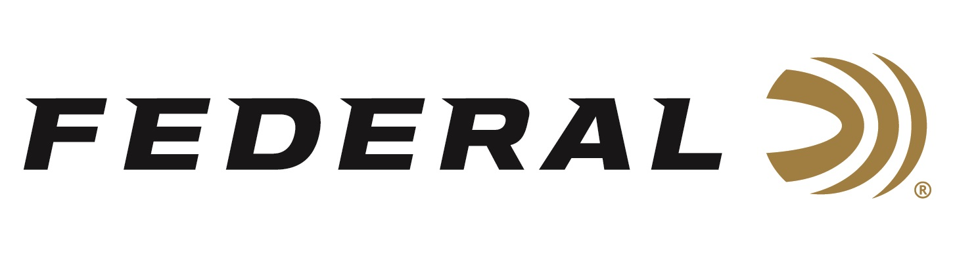

FOR IMMEDIATE RELEASE

Sporting Arms and Ammunition Manufacturers' Institute Publishes
30 Super Carry Cartridge Specifications

ANOKA, Minnesota – July 15, 2022 – The Sporting Arms and Ammunition Manufacturers' Institute (SAAMI) voted to approve the Federal Premium 30 Super Carry as an official new pistol cartridge. Federal’s 30 Super Carry’s SAAMI standards documents are now published and available to the industry, as well as to the public.

“At Federal, we are once again excited to have a new cartridge approved by SAAMI,” said Jesse Whiteside, Federal’s Senior Director of Product Management. “This shows the 30 Super Carry meets the strict standards set forth by the organization. With SAAMI’s standards published for the 30 Super Carry, it will help expand this excellent personal defense cartridge to be used in more firearm platforms across the industry.”

SAAMI allows free access to technical data and drawings for the cartridge and chamber designs, which are posted in the Information and Specifications section of the organization’s website. All cartridge and chamber drawing documents are contained within the ANSI/SAAMI Standards and can be found on www.saami.org. The New SAAMI Cartridge Cartridge/Chamber Designs and Revisions for the 30 Super Carry can be viewed here: https://saami.org/wp-content/uploads/2022/07/Public-Introduction-30-Super-Carry-2022-06-30.pdf.

With the new 30 Super Carry Cartridge, personal defense users won’t have to choose between a smaller platform with reduced bullet performance or a larger platform to carry more rounds. The 30 Super Carry has better terminal performance than a 380 Auto and as much muzzle energy as a 9mm Luger, all with a .313-inch projectile. Users will see performance like 9mm Luger with slightly less recoil and additional magazine capacity.

Federal currently offers the 30 Super Carry in a 100-grain HST Jacketed Hollow Point (JHP) load in a 20-count box. The load is also available in the American Eagle 30-Super Carry 100-grain, Full Metal Jacket (FMJ) load in a 50-count box.

SAAMI was founded in 1926 at the request of the federal government and tasked with creating and publishing industry standards for safety, interchangeability, reliability, and quality, as well as coordinating technical data. SAAMI’s Technical Committee, which consists of firearm and ammunition industry experts, reviewed the 30 Super Carry submission over a period of about six months. The official cartridge name, maximum cartridge and minimum chamber dimensions, pressure limits, test equipment, and other characteristics are all considered and scrutinized during the process.

Federal ammunition can be found at dealers nationwide or purchased online direct from Federal. For more information on all products from Federal or to shop online, visit www.federalpremium.com.

Press Release Contact: JJ Reich
Senior Manager – Press Relations
E-mail: VistaPressroom@VistaOutdoor.com

About Federal Ammunition
Federal, headquartered in Anoka, MN, is a brand of Vista Outdoor Inc., an outdoor sports and recreation company. From humble beginnings nestled among the lakes and woods of Minnesota, Federal Ammunition has evolved into one of the world's largest producers of sporting ammunition. Beginning in 1922, founding president, Charles L. Horn, paved the way for our success. Today, Federal carries on Horn's vision for quality products and service with the next generation of outdoorsmen and women. We maintain our position as experts in the science of ammunition production. Every day we manufacture products to enhance our customers' shooting experience while partnering with the conservation organizations that protect and support our outdoor heritage. We offer thousands of options in our Federal Premium and Federal® lines-it's what makes us the most complete ammunition company in the business and provides our customers with a choice no matter their pursuit.

