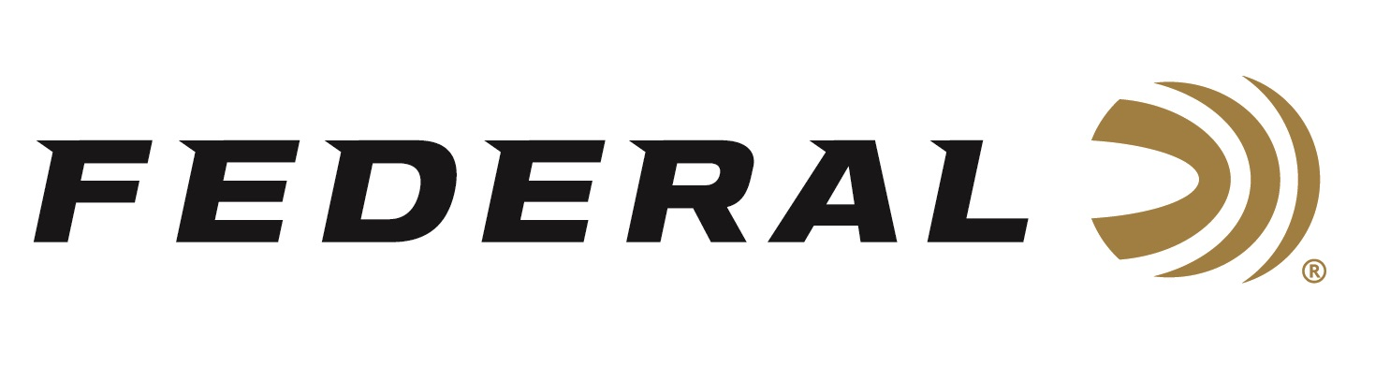
FOR IMMEDIATE RELEASE

Federal is the Official Ammunition of Silencer Central

ANOKA, Minnesota – January 24, 2023 – Federal Ammunition, the industry's ammunition technology leader, is the Official Ammunition of Silencer Central. Federal’s President Jason Vanderbrink and Silencer Central’s Chief Executive Officer Brandon Maddox recently announced the partnership at the 2023 SHOT Show in Las Vegas, Nevada. This collaboration also names Silencer Central as the Official Silencer of Federal Ammunition.

“We are excited for the opportunity to work so closely with the entire team at Silencer Central,” said Vanderbrink. “A strong partnership with them just makes sense as new products are developed to better serve the shooter and hunter with innovative products. Our companies will continue to collaborate on content creation to further educate on the benefits of shooting with a suppressor. Other promotional activities will be designed around the safety and comfort of suppressed shooting and the right ammunition pairings, helping to make them more efficient and effective.”

Since the fall of 2022, Federal ammunition has been working with Silencer Central to develop content on its brand’s website and E-newsletters to educate its core users, as well as Federal ambassador and event collaboration and promotions.

Examples of marketing efforts include recent Federal e-newsletters that gave subscribers the first shot at purchase Silencer Central’s newest suppressor, the BANISH Backcountry, before it went up for sale to the public; a helpful guide that explained the benefits of suppressors, how they work, and what the purchase process is like; and a promo code to get a free wrap with the purchase of any Banish suppressor from Silencer Central.

“There are many reasons why suppressors are getting more popular every day,” continued Vanderbrink. “It's about more than just turning down the volume. Many other advantages come from shooting or hunting with a suppressor, and our collaboration with Silencer Central will continue to help deliver those important messages.”

For more information on all products from Federal or to shop online, visit www.federalpremium.com.

Press Release Contact: JJ Reich
Senior Manager – Press Relations
E-mail: VistaPressroom@VistaOutdoor.com

About Federal Ammunition
Federal, headquartered in Anoka, MN, is a brand of Vista Outdoor Inc., an outdoor sports and recreation company. From humble beginnings nestled among the lakes and woods of Minnesota, Federal Ammunition has evolved into one of the world's largest producers of sporting ammunition. Beginning in 1922, founding president, Charles L. Horn, paved the way for our success. Today, Federal carries on Horn's vision for quality products and service with the next generation of outdoorsmen and women. We maintain our position as experts in the science of ammunition production. Every day we manufacture products to enhance our customers' shooting experience while partnering with the conservation organizations that protect and support our outdoor heritage. We offer thousands of options in our Federal Premium and Federal® lines-it's what makes us the most complete ammunition company in the business and provides our customers with a choice no matter their pursuit.

