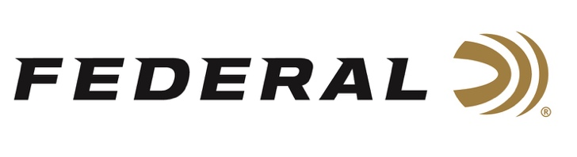

FOR IMMEDIATE RELEASE

Federal Ammunition and Champion Targets Award Tom Knapp Memorial Scholarships

ANOKA, Minnesota – July 13, 2022 – At the recent National 4-H Shooting Sports Invitational held in Grand Island, Nebraska, two National 4-H Shooting Sports Ambassadors were awarded the 9th annual Tom Knapp Memorial Scholarships. The national event brought together nearly 700 competitors from 39 states to participate in a multitude of shooting sports disciplines. Their shooting skills shined throughout the week and their enthusiasm spilled over to the community.

Applicants for the scholarship are required to have attended the National 4-H Shooting Sports Ambassador training, maintain at least a 3.0 GPA, and be enrolled or planning to attend an accredited college or university. Faith Newton from North Carolina and William Elrod from Georgia were chosen as the 2022 scholarship recipients.

Although all the applicants were outstanding these two ambassadors stood out in the applications with their numerous volunteer efforts not only in their local communities but throughout their states and regions. All the 4-H Shooting Sports Ambassadors are true leaders in their communities and within the shooting sports industry.

“The Knapp Family would be proud of all the National 4-H Ambassador’s and their shooting accomplishments. These annual scholarships have changed the lives of dozens of kids over the years and this group does a tremendous job at sharing the positive effects that the 4-H Shooting Sports Program has had on their lives and communities across the country,” said Brian Kelvington from Federal Ammunition. Kelvington assisted the Knapp Family with putting together this scholarship program which started in 2014.

2022 marks the 7th year of scholarships awarded to 4-H Ambassadors with 14 youth in total receiving scholarships from this program since 2016. Federal Ammunition continues to be the longest tenured sponsor for the National 4-H Shooting Sports Program who reaches over 500,000 youth from across the country. The program promotes firearm safety, youth development through structured shooting sports programs across all shooting disciplines.

For more information on all products from Federal or to shop online, visit www.federalpremium.com.
Press Release Contact: JJ Reich
Senior Manager – Press Relations
E-mail: VistaPressroom@VistaOutdoor.com

About Federal Ammunition
Federal, headquartered in Anoka, MN, is a brand of Vista Outdoor Inc., an outdoor sports and recreation company. From humble beginnings nestled among the lakes and woods of Minnesota, Federal Ammunition has evolved into one of the world's largest producers of sporting ammunition. Beginning in 1922, founding president, Charles L. Horn, paved the way for our success. Today, Federal carries on Horn's vision for quality products and service with the next generation of outdoorsmen and women. We maintain our position as experts in the science of ammunition production. Every day we manufacture products to enhance our customers' shooting experience while partnering with the conservation organizations that protect and support our outdoor heritage. We offer thousands of options in our Federal Premium and Federal® lines-it's what makes us the most complete ammunition company in the business and provides our customers with a choice no matter their pursuit.

###

