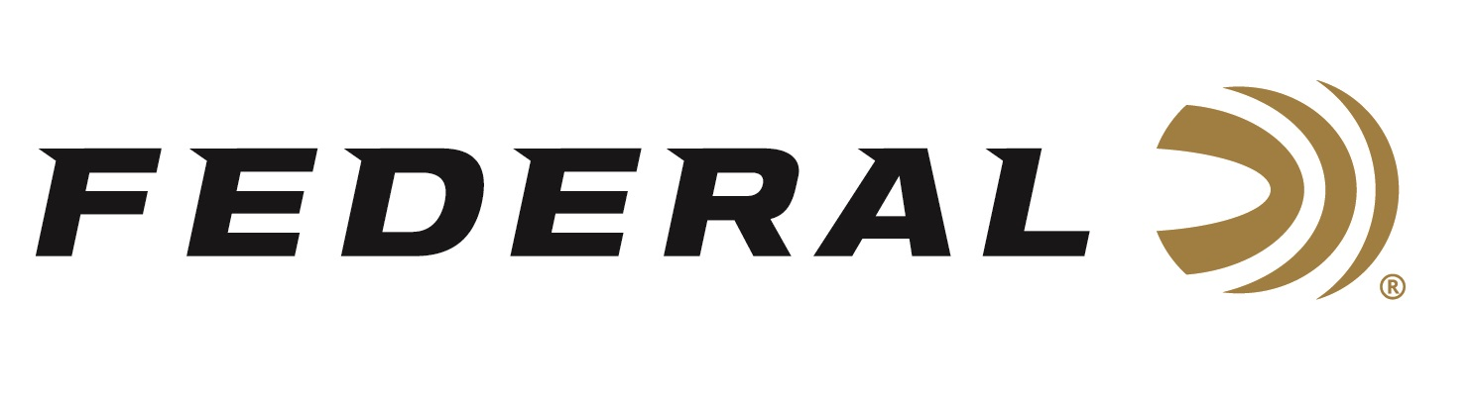

FOR IMMEDIATE RELEASE

Federal Ammunition Adds Paper Wad Options to Popular Top Gun Shotshell Line

ANOKA, Minnesota – November 17, 2022 – Federal Ammunition adds paper wad options to select Federal Top Gun lead and steel shotshell loads. This new shotshell offering adds another option to the trusted line of Federal Top Gun shotshells. This new ammunition has been shipping to dealers.

To accomplish consistent shooting performance with a paper wad, Federal engineers combined an exclusive paper wad with a cellulose-based filler to maintain downrange patterns. The Top Gun with Paper Wad additions are built with a select, clean-burning propellant and a paper gas-sealing over-powder wad. Clay target shooters need reliable ignition from their shotshells and the Top Gun with Paper Wad boast Federal’s reliable primers that shooters have come to trust.

“The paper wad system we have developed is proving to be a real solid performer from a patterning standpoint,” said Dan Compton, Federal Shotshell Product Director. “Our goal was to make the shooting experience seamless between a traditional polymer to this new paper system and our engineers feel we have accomplished that. This paper wad system will also be used in a wide variety of other shotshell product lines soon.”

The Top Gun with Paper Wad shotshells will be available for 12 gauge in four offerings. Two steel shot versions with 7.5 shot size and two lead offerings in 7.5 or 8 shot sizes. These loads are available with high-quality lead or steel payloads.

For more information on all products from Federal or to shop online, visit www.federalpremium.com.

Press Release Contact: JJ Reich
Senior Manager – Press Relations
E-mail: VistaPressroom@VistaOutdoor.com

About Federal Ammunition
Federal, headquartered in Anoka, MN, is a brand of Vista Outdoor Inc., an outdoor sports and recreation company. From humble beginnings nestled among the lakes and woods of Minnesota, Federal Ammunition has evolved into one of the world's largest producers of sporting ammunition. Beginning in 1922, founding president, Charles L. Horn, paved the way for our success. Today, Federal carries on Horn's vision for quality products and service with the next generation of outdoorsmen and women. We maintain our position as experts in the science of ammunition production. Every day we manufacture products to enhance our customers' shooting experience while partnering with the conservation organizations that protect and support our outdoor heritage. We offer thousands of options in our Federal Premium and Federal® lines-it's what makes us the most complete ammunition company in the business and provides our customers with a choice no matter their pursuit.

