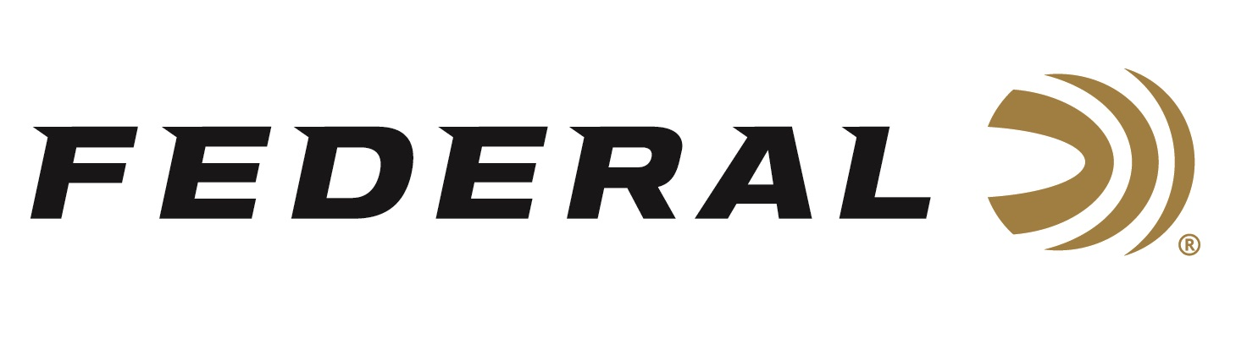

FOR IMMEDIATE RELEASE

Team Federal Finished Strong at the 2022 Ruger Classic Nationals

ANOKA, Minnesota – May 27, 2022 – Team Federal had a strong showing at the 2022 Ruger Classic Nationals match held at CMP Marksmanship Park in Talladega, Alabama. Federal Ammunition was the presenting sponsor of the event. Team Federal shooters participating at the event were Todd Jarrett, Casey Reed and Travis Tomasie shooting the Limited 10 division and Tim Herron shooting the Single Stack division.

“The USPSA staff and the team at the CMP Marksmanship Park in Talladega did a fantastic job putting the match together. This match attracted nearly 300 of the top competitive pistol shooters in the world,” said Jason Spradling, Federal’s Shooting Sports Promotions Manager. “Jarrett shot a great match and I’m proud that he depends on Federal ammunition to give him the accuracy and reliability he needs to compete at such a high level. It was great to see his two Federal teammates right on his heels. Congratulations to these shooters, they certainly work hard for it.”

Team Federal shooter Todd Jarrett finished seventh overall and third in the Limited 10 division where he also took High Senior honors. He was joined in the top five finishers in the Limited 10 division by teammates Travis Tomasie who took fourth place, and Casey Reed who finished fifth. Ammunition used by Team Federal at this match included Federal American Eagle FMJ and Syntech Action Pistol TSJ.

“I want to give a big thanks to Federal for supporting the shooting sports and their sponsorship of the 2022 USPSA Classic Nationals,” said Jarrett. “I was fortunate enough to finish third overall and high senior using my American Eagle 180-grain, 40 S&W ammo. They are perfect for practice and in important matches like this when every shot counts.”

For more information on all products from Federal or to shop online, visit www.federalpremium.com.

Press Release Contact: JJ Reich
Senior Manager – Press Relations
E-mail: VistaPressroom@VistaOutdoor.com

About Federal Ammunition
Federal, headquartered in Anoka, MN, is a brand of Vista Outdoor Inc., an outdoor sports and recreation company. From humble beginnings nestled among the lakes and woods of Minnesota, Federal Ammunition has evolved into one of the world's largest producers of sporting ammunition. Beginning in 1922, founding president, Charles L. Horn, paved the way for our success. Today, Federal carries on Horn's vision for quality products and service with the next generation of outdoorsmen and women. We maintain our position as experts in the science of ammunition production. Every day we manufacture products to enhance our customers' shooting experience while partnering with the conservation organizations that protect and support our outdoor heritage. We offer thousands of options in our Federal Premium and Federal® lines-it's what makes us the most complete ammunition company in the business and provides our customers with a choice no matter their pursuit.

