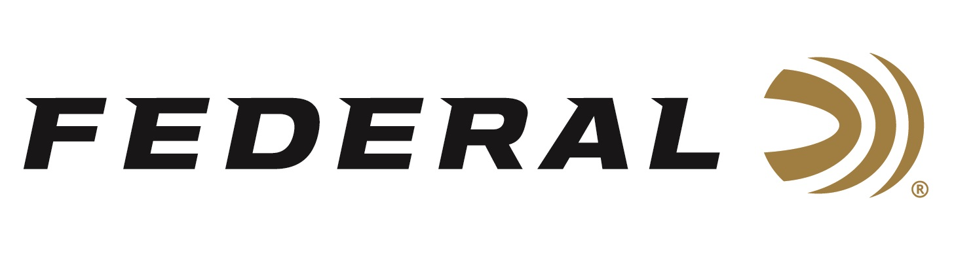

FOR IMMEDIATE RELEASE

Team Federal Reaches the Podium at the 2022 USPSA Multigun Nationals

ANOKA, Minnesota – April 6, 2022 – Team Federal brings home some impressive hardware from the 2022 USPSA Multigun Nationals recently held at the Clinton House Plantation in Clinton, South Carolina. Josh Froelich finished second in the Open Division and Konnor Fryburger placed second in the Limited Division. The field of 139 shooters participated in the first Multigun National event held in two years.

“The 2022 USPSA Multigun Nationals match was a tremendous success and Federal is proud to have been the presenting sponsor,” said Jason Spradling, Federal’s Shooting Sports Promotions Manager. “Josh Froelich is an intense competitor and his excellent finish in a stacked field of competitors proved that. Konnor Fryburger also put forth a tremendous performance. At just 17 years old, he is one of Team Federal’s newest team members, and he certainly made his presence known at this competition.”

“This year’s Multigun Nationals was a fast-paced, fun match with almost no room for error on stages without losing points,” said Konnor Fryburger. “I really appreciate the effort from USPSA to make the rules more accommodating for 3-gunners, it allows the match to have a more relaxed and fun atmosphere.”

“Shannon Smith and his crew at the USPSA executed a well-run match with a course of fire that demanded detailed stage planning and flawless execution of fundamentals to score well,” continued Spradling. “Team Federal looks forward to continued competition success in 2022. We have an excellent group of shooters and high-performance ammunition products to help them be successful.”

For more information on all products from Federal or to shop online, visit www.federalpremium.com.

(Photo: Josh Froelich on left receiving trophy.)

Press Release Contact: JJ Reich
Senior Manager – Press Relations
E-mail: VistaPressroom@VistaOutdoor.com

About Federal Ammunition
Federal, headquartered in Anoka, MN, is a brand of Vista Outdoor Inc., an outdoor sports and recreation company. From humble beginnings nestled among the lakes and woods of Minnesota, Federal Ammunition has evolved into one of the world's largest producers of sporting ammunition. Beginning in 1922, founding president, Charles L. Horn, paved the way for our success. Today, Federal carries on Horn's vision for quality products and service with the next generation of outdoorsmen and women. We maintain our position as experts in the science of ammunition production. Every day we manufacture products to enhance our customers' shooting experience while partnering with the conservation organizations that protect and support our outdoor heritage. We offer thousands of options in our Federal Premium and Federal® lines-it's what makes us the most complete ammunition company in the business and provides our customers with a choice no matter their pursuit.

