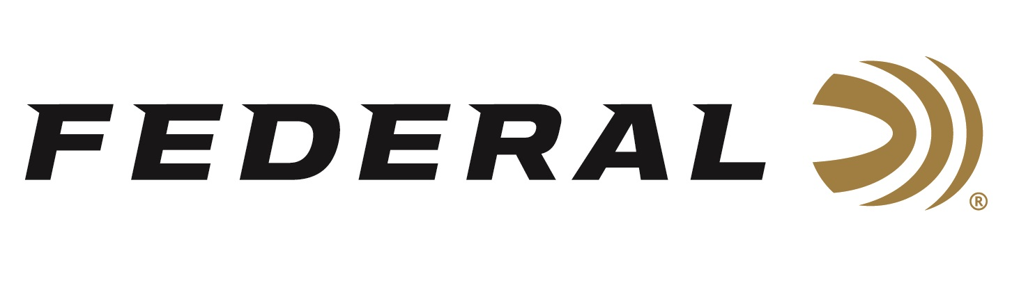

FOR IMMEDIATE RELEASE

Federal Ammunition Shooter Vincent Hancock Qualifies the U.S.A. for Olympic Games

ANOKA, Minnesota – October 10, 2022 – Federal Ammunition sponsored shooter and three-time Olympic champion Vincent Hancock won Silver in Men Skeet at the 2022 International Shooting Sport Federation (ISSF) World Championship, held in Osijek, Croatia. With the win, Hancock has now qualified the U.S.A. for a quota spot in Men Skeet for the 2024 Summer Olympic Games in Paris, France.

“Vincent has set the bar for international skeet shooting in our country and also represented the U.S.A. in Tokyo with a stellar performance,” said Federal Ammunition’s Vice President of Marketing Jason Nash. “We are eager and excited to see him qualify for Team USA and shoot for yet another Olympic gold. His accomplishments reflect Federal’s dedication to its quality products and to the shooting sports.”

The medal won at this Championship match adds to an already accomplished-filled 2022 shooting season for Hancock, who won gold at the 2022 Skeet Nationals Championship this past summer in Hillsdale, Michigan. He also won three gold medals in individual and team shooting events at the 2022 ISSF World Cup in Baku, Azerbaijan.

“My 2022 season has been a big success and certainly has been one to remember,” said Hancock. “This was a fun and challenging event with some great competitors. I was happy that I was able to perform well enough to secure a quota spot for the upcoming biggest event in the world which is Paris 2024. I thank my sponsors, which includes Federal Ammunition, for being my partners and providing the gear needed to succeed.”

Federal ammunition can be found at dealers nationwide. For more information on all products from Federal or to shop online, visit www.federalpremium.com.

Press Release Contact: JJ Reich
Senior Manager – Press Relations
E-mail: VistaPressroom@VistaOutdoor.com

About Federal Ammunition
Federal, headquartered in Anoka, MN, is a brand of Vista Outdoor Inc., an outdoor sports and recreation company. From humble beginnings nestled among the lakes and woods of Minnesota, Federal Ammunition has evolved into one of the world's largest producers of sporting ammunition. Beginning in 1922, founding president, Charles L. Horn, paved the way for our success. Today, Federal carries on Horn's vision for quality products and service with the next generation of outdoorsmen and women. We maintain our position as experts in the science of ammunition production. Every day we manufacture products to enhance our customers' shooting experience while partnering with the conservation organizations that protect and support our outdoor heritage. We offer thousands of options in our Federal Premium and Federal® lines-it's what makes us the most complete ammunition company in the business and provides our customers with a choice no matter their pursuit.

