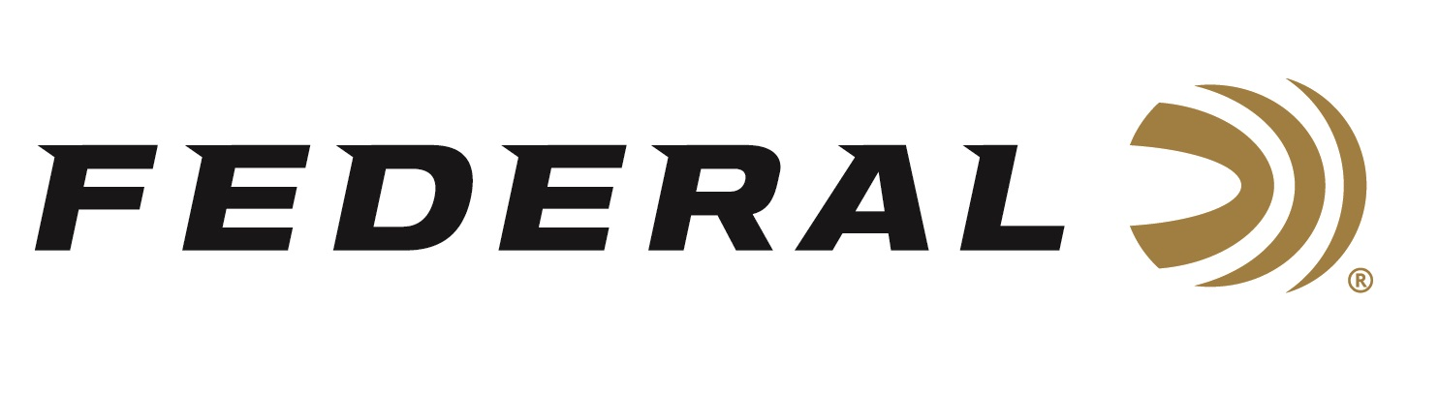

FOR IMMEDIATE RELEASE

Federal Ammunition Shooter Vincent Hancock Takes Home Two Medals at the ISSF World Championship

ANOKA, Minnesota – October 27, 2022 – Federal Ammunition congratulates sponsored shooter Vincent Hancock—a three-time Olympic gold medalist and four-time World Champion—for winning two Silver medals at the 2022 International Shooting Sport Federation (ISSF) World Championship, held in Osijek, Croatia. Hancock brought home a silver medal in Men’s Individual Skeet and a silver medal in Men’s Team Skeet with U.S. teammates Dustan Taylor and Christian Elliott.

"This was a great event for me and for many other athletes on Team USA Shooting. My goal is to always do my best, and this match was a close one in all regards,” said Hancock. “I shot a great final but came up just one target short as the Gold medal was taken by Azmy Mehelba of Egypt with a perfect score that matched the World Record. The Men’s Team event went great as well, with us getting a silver medal there too. Overall, I’m proud of my teammates and their dedication to working hard and doing their best!”

“We are truly proud to be Hancock’s sponsor,” said Federal Ammunition’s Shotshell Product Director Dan Compton. “His personality, performances and accomplishments reflect Federal’s dedication to its quality products and to the shooting sports.”

“I shoot all over the world, and Federal Ammunition will always be my first choice. On the range, I know that the reliability and quality of Federal’s ammo is second to none and I can trust it in any conditions,” continued Hancock. “Federal is a big reason I can do what I do as a professional athlete. They support my family and me on my journey to the Olympics, and they are always willing to go above and beyond to ensure their athletes have what they need and can be successful in chasing their dreams.”

Federal ammunition can be found at dealers nationwide. For more information on all products from Federal or to shop online, visit www.federalpremium.com.

Press Release Contact: JJ Reich
Senior Manager – Press Relations
E-mail: VistaPressroom@VistaOutdoor.com
About Federal Ammunition
Federal, headquartered in Anoka, MN, is a brand of Vista Outdoor Inc., an outdoor sports and recreation company. From humble beginnings nestled among the lakes and woods of Minnesota, Federal Ammunition has evolved into one of the world's largest producers of sporting ammunition. Beginning in 1922, founding president, Charles L. Horn, paved the way for our success. Today, Federal carries on Horn's vision for quality products and service with the next generation of outdoorsmen and women. We maintain our position as experts in the science of ammunition production. Every day we manufacture products to enhance our customers' shooting experience while partnering with the conservation organizations that protect and support our outdoor heritage. We offer thousands of options in our Federal Premium and Federal® lines-it's what makes us the most complete ammunition company in the business and provides our customers with a choice no matter their pursuit.

