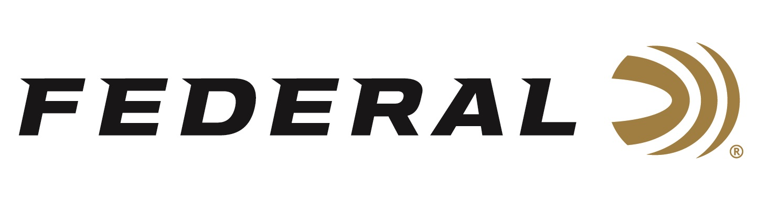

FOR IMMEDIATE RELEASE

**Federal Ammunition Shooter Vincent Hancock Takes Home Silver and Gold the 2023 ISSF World Championship**

**ANOKA, Minnesota – March 8, 2023 –** Federal Ammunition congratulates sponsored shooter Vincent Hancock—a three-time Olympic gold medalist and four-time World Champion—for winning two medals at the 2023 International Shooting Sports Federation (ISSF) World Cup in Doha, Qatar, March 4-13. Hancock brought home a Silver medal in Men’s Individual Skeet and a Gold medal in Mixed Team Skeet with U.S. teammate Kim Rhode.

“I shot one of the best matches of my career in Doha this week,” said Hancock. “I achieved a World Record tying score of 125/125, a perfect semifinal, and then I just fell a single target short of Gold in the Men’s Individual Skeet Final. Overall, I’m very happy with how I’m shooting and really looking forward to continuing to get better going into Paris 2024!”

“We are truly proud to be Hancock’s sponsor,” said Federal Ammunition’s Shotshell Product Director Dan Compton. “His personality, performances and accomplishments reflect Federal’s dedication to its quality products and to the shooting sports.”

"This was a great event for me and for many other athletes on Team USA Shooting. My goal is to always do my best, and the Men’s Individual Skeet match was certainly a close one,” continued Hancock. “I shoot all over the world, and Federal Ammunition will always be my first choice. On the range, I know that the reliability and quality of Federal’s ammo is second to none and I can trust it in any conditions.”

Federal ammunition can be found at dealers nationwide. For more information on all products from Federal or to shop online, visit [www.federalpremium.com](http://www.federalpremium.com).

**Press Release Contact: JJ Reich**

Senior Manager – Press Relations

E-mail: [VistaPressroom@VistaOutdoor.com](mailto:VistaPressroom@VistaOutdoor.com)

**About Federal Ammunition**

Federal, headquartered in Anoka, MN, is a brand of Vista Outdoor Inc., an outdoor sports and recreation company. From humble beginnings nestled among the lakes and woods of Minnesota, Federal Ammunition has evolved into one of the world's largest producers of sporting ammunition. Beginning in 1922, founding president, Charles L. Horn, paved the way for our success. Today, Federal carries on Horn's vision for quality products and service with the next generation of outdoorsmen and women. We maintain our position as experts in the science of ammunition production. Every day we manufacture products to enhance our customers' shooting experience while partnering with the conservation organizations that protect and support our outdoor heritage. We offer thousands of options in our Federal Premium and Federal® lines-it's what makes us the most complete ammunition company in the business and provides our customers with a choice no matter their pursuit.