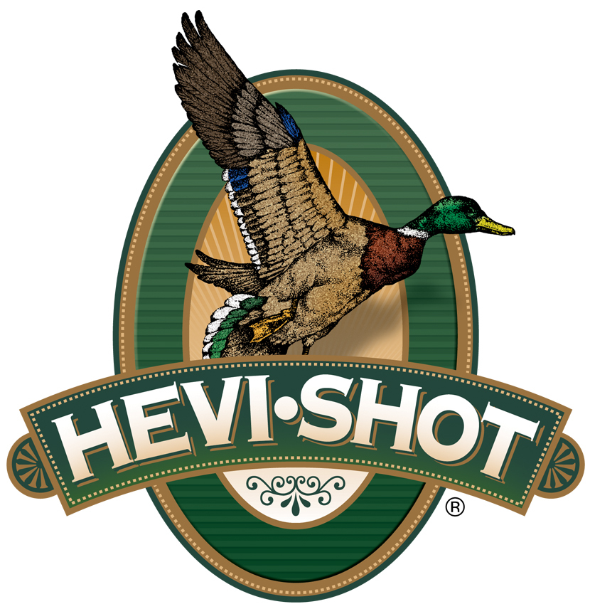

FOR IMMEDIATE RELEASE

HEVI-Shot Showcases HEVI-18 TSS Turkey Loads at the
2022 NWTF Sport Show

SWEET HOME, Oregon – February 22, 2022 – Visitors to HEVI-Shot booth at the National Wild Turkey Federation’s (NWTF) 46th Annual Convention and Sport Show, held February 16-20, 2022 in Nashville, Tennessee, saw firsthand the turkey load product lines from HEVI-Shot, including HEVI-18 TSS. These shotshells are packed with TSS 18 g/cc density pellets for long-range performance and high pellet count. Hevi-18 TSS Turkey are offered in No. 7 and No. 9 shot sizes for 12 and 20 gauge and .410 bore shotguns.

“TSS shot is an excellent option for turkey hunters, and we are excited to feature it in the new HEVI-18 shotshells,” said Scott Turner, HEVI-Shot’s Product Line Manager. "A great benefit of this load is that hunters have an extremely effective .410 option without sacrificing performance. This allows hunters of all ages and sizes to be able to carry a smaller shotgun without having to second guess the shotshell payload or penetrating power.”

Tungsten Super Shot (TSS) has been a proven performer in the turkey woods. HEVI-18 TSS features an ultra-high pellet density of 18 grams per cubic centimeter, is 56 percent denser than lead, and is harder than steel. The increased pellet density results in an extended lethal range of the payload. For all-weather reliability in semi-automatic shotguns, the shotshells feature a thicker base-wad, hotter primer, and clean-burning propellants.

“With the increased density of TSS, we can feature smaller pellets in our offerings, increasing the pellet count. This results in better pattern densities without sacrificing penetration,” continued Turner. “A No. 9 TSS pellet carries at least as much penetration as a No. 5 lead pellet at the same ranges.”

HEVI-18 TSS Turkey is available in two 3-inch and 3-1/2-inch 12-gauge options in No. 7 or No. 9 shot with charge weights of 2 ounces in 3-inch and 2-1/4 in 3-1/2-inch shotshells. All 12-gauge options feature a 1,250 feet-per-second (FPS) velocity. Two 3-inch 20-gauge options are available in No. 7 or No. 9 shot size with a 1-1/2 ounce charge weight and 1,250 FPS velocity. For those that prefer a .410 bore, a No. 7 and No. 9 shot size will be available in a 3-inch shotshell with a 13/16-ounce charge weight and FPS velocity of 1,090. Each HEVI-18 TSS Turkey is sold in boxes of 5.

For more information on all products from HEVI-Shot, visit www.hevishot.com.

Press Release Contact: JJ Reich
Senior Manager – Press Relations
E-mail: VistaPressroom@VistaOutdoor.com

About HEVI-Shot
Established in 2000 and based out of Sweet Home, Oregon, HEVI-Shot is a brand of Vista Outdoor Inc., an outdoor sports and recreation company. HEVI-Shot is an industry leader In performance shotshell, providing the next generation of shotshell loads to hunters—with their large and impressive selection of hunting ammunition options. HEVI-Shot is synonymous with high performance projectiles. The company meticulously designs each product to outperform any ammunition competitor in its class. That is why HEVI-Shot is the ammunition choice for serious hunters who live by their slogan: “I DIDN’T COME THIS FAR TO MISS!”

