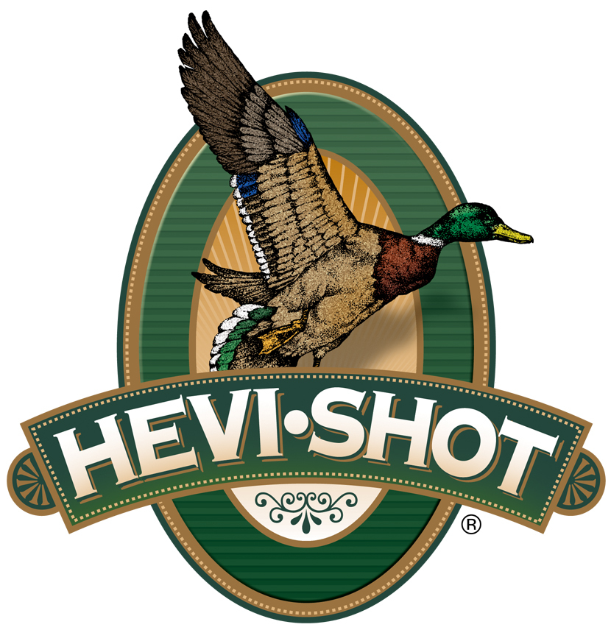

FOR IMMEDIATE RELEASE

HEVI-Shot Ammunition to Sponsor and Attend the at 2022 Delta Waterfowl Expo

SWEET HOME, Oregon – July 27, 2022 – HEVI-Shot Ammunition will join the 2022 Delta Waterfowl Expo as an exhibitor and Teal Level Sponsor. The Expo will be held July 29-31, 2022 at the Little Rock Statehouse Convention Center in Little Rock, Arkansas. Attendees of the event can visit booth no. 257 to see the latest hunting ammunition from HEVI-Shot.

“HEVI-Shot is proud to be one of the exhibitors and sponsors of the 2022 Delta Waterfowl Expo,” said Scott Turner, HEVI-Shot’s Product Manager. “We want to continue to help promote and support the mission of Delta Waterfowl and the great research and conservation work they are doing. We look forward to meeting with all the like-minded waterfowl enthusiasts at the Expo.”

HEVI-Shot is the original and premier manufacturer of non-toxic ammunition and performs better than lead. The original HEVI-Shot loads are specially formulated for waterfowlers, upland hunting, coyote control, and turkey hunting. HEVI-Bismuth, HEVI-Steel, and HEVI-Hammer lines of shotgun ammo continue to be top performers for hunters.

Building on a legacy of conservation and management programs, the Delta Waterfowl Expo brings waterfowl hunters together. Over the three-day event, attendees can see the latest waterfowl gear, meet waterfowl hunters from all over the country, participate in raffles, and learn from experts at numerous seminars. The 2022 Delta Waterfowl Expo will continue to help Delta Waterfowl in their mission to create more waterfowl habitat back by proven conservation methods.

Visitors to www.hevishot.com are encouraged to sign up for HEVI-Shot’s e-newsletter or follow HEVI-Shot on social media to be the first to hear about exciting new products The HEVI-Shot outlets keep users informed on product availability and view their entire product catalog online.

For more information on all products from HEVI-Shot, visit www.hevishot.com.

Press Release Contact: JJ Reich
Senior Manager – Press Relations
E-mail: VistaPressroom@VistaOutdoor.com

About HEVI-Shot
Established in 2000 and based out of Sweet Home, Oregon, HEVI-Shot is a brand of Vista Outdoor Inc., an outdoor sports and recreation company. HEVI-Shot is an industry leader in performance shotshell, providing the next generation of shotshell loads to hunters—with their large and impressive selection of hunting ammunition options. HEVI-Shot is synonymous with high performance projectiles. The company meticulously designs each product to outperform any ammunition competitor in its class. That is why HEVI-Shot is the ammunition choice for serious hunters who live by their slogan: “I DIDN’T COME THIS FAR TO MISS!”

