FOR IMMEDIATE RELEASE

Remington Joins Federal in 30 Super Carry ‘Ammo of the Year’ Win

Lonoke, Arkansas – November 14, 2022 – Guns & Ammo Magazine recently announced 30 Super Carry as the winner of 2022 Ammo of the Year. The award comes as a new class of ammunition and a much-needed advancement in self-defense is introduced to the industry.

Remington Ammunition offers multiple well received loads for this exciting new cartridge. The company currently offers a 30 Super Carry full metal jacket load in UMC Handgun as well as a jacketed hollow point in High Terminal Performance Handgun, providing exceptional options for target shooting, personal defense and concealed carry.

“During Guns & Ammo’s extensive testing of this cartridge, we found it to be accurate, reliable and effective in ballistic gel to 12 inches. The .30 SC projectile typically expands as well and penetrates as deep as a comparable 9mm load,” said the Guns & Ammo staff in the review article.

Targeting the gap between 9mm Luger and 380 Auto, 30 Super Carry offers more capacity than a traditional 9mm and improved terminal performance than a 380 Auto.

With over 300 years of combined experience, Remington Ammunition is excited to support Federal in their Ammo of the Year 2022 award as each company continuously pursues engineering advancements and innovation.

For more information, visit www.remington.com/handgun/.

Find Remington ammunition at dealers nationwide and online. For more information on Remington ammunition and accessories, visit www.remington.com.

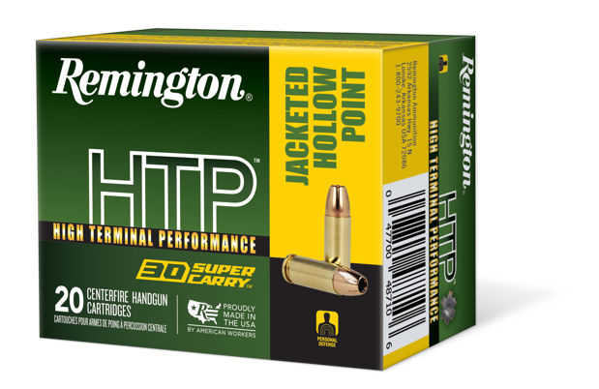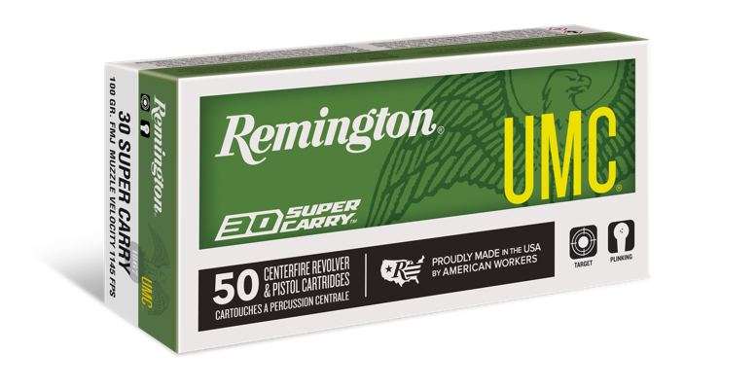

Press Release Contact: Jonathan Harling
Remington Public Relations
E-mail: remingtonammopr@murrayroadagency.com

About Remington
From muskets to modern day, generations of hunters and shooters have trusted Remington ammunition and accessories. Loaded in Lonoke, Arkansas by American workers, our wide array of pioneering sporting and hunting ammunition promises to get the job done every time the trigger is pulled. At Remington, we’re here for everyone who loads a round of ammo into a handgun, rifle, or shotgun.

We’ve been here since 1816. Together, Remington and America have fought and won wars, put food on millions of tables and brought countless generations together at the range and in the field. We are proud of each and every round that rolls off our factory line. A brand of outdoor sports and recreation company Vista Outdoor, Remington is bringing a renewed focus to ammunition, innovation, and quality – all while staying true to Remington’s legendary heritage and stature as an American icon.

