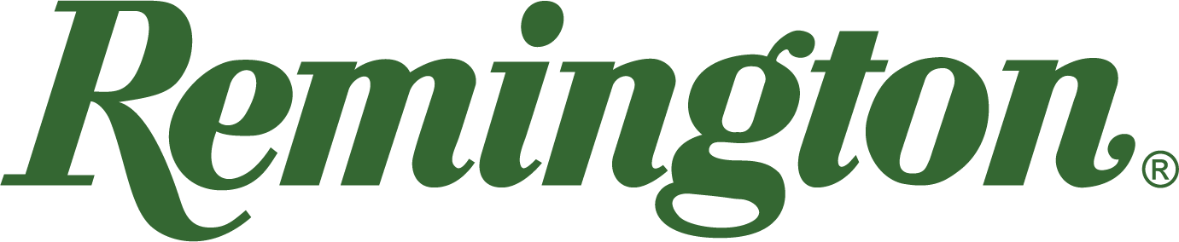

FOR IMMEDIATE RELEASE

Remington Ammunition to Sponsor and Attend the 2022 Delta Waterfowl Expo

Lonoke, Arkansas – July 26, 2022 – Remington Ammunition will be on site as a Bluebill level sponsor and attendee of the 2022 Delta Waterfowl Duck Hunters Expo in Little Rock, Arkansas. Fans should visit the Remington booth to see the full assortment of Big Green ammunition and for a chance to win various prizes. Additionally, attendees will also be able to purchase exclusive Remington merchandise. The event is set to take place July 29-31 at the Little Rock Statehouse Convention Center.

“We are very excited to be at the Delta Waterfowl Expo,” said Remington’s Director of Marketing Joel Hodgdon. “Remington’s been part of the Arkansas conservation community since our Lonoke, AR factory was built in the 60’s. We see no better place to meet fans and talk to duck hunters than the duck hunting capital of the world. It is an honor to support Delta in their mission.”

The 2022 Delta Waterfowl Duck Hunters Expo will have presentations and experiences related to hunting, conservation and heritage. With something for everyone, attendees can find the latest in duck hunting while experiencing expert seminars, raffles, a duck dog parade, contests and more. Tickets are available at www.deltawaterfowlexpo.com for general admission and some special events.

Delta Waterfowl is the Duck Hunters Organization, a leading conservation group founded at the famed Delta Marsh in Manitoba. Its U.S. headquarters is in Bismarck, North Dakota. They work to produce ducks through intensive management programs and conservation of breeding duck habitat. Delta conducts vital waterfowl research and promotes and protects the continuing tradition of waterfowl hunting in North America.

To be the first to hear about product availability, exciting new products and everything Remington ammo, visitors to www.remington.com are encouraged to sign up for Remington’s e-newsletter or follow Remington on social media.

Press Release Contact: Jonathan Harling
Remington Public Relations
E-mail: remingtonammopr@murrayroadagency.com

About Remington

From muskets to modern day, generations of hunters and shooters have trusted Remington ammunition and accessories. Loaded in Lonoke, Arkansas by American workers, our wide array of pioneering sporting and hunting ammunition promises to get the job done every time the trigger is pulled. At Remington, we’re here for everyone who loads a round of ammo into a handgun, rifle, or shotgun.

We’ve been here since 1816. Together, Remington and America have fought and won wars, put food on millions of tables and brought countless generations together at the range and in the field. We are proud of each and every round that rolls off our factory line. A brand of outdoor sports and recreation company Vista Outdoor, Remington is bringing a renewed focus to ammunition, innovation, and quality – all while staying true to Remington’s legendary heritage and stature as an American icon.

