FOR IMMEDIATE RELEASE

Remington Ammunition Introduces Remington Range

Lonoke, Arkansas – January 18, 2023 – Remington Ammunition is proud to present Remington Range, the handgun load that delivers shot-to-shot consistency and serves as the ideal choice for everyday plinking. Now available nationwide, Remington Range is every first-time shooter or range expert’s go-to practice round.

“With tons of new innovative products coming from Big Green this year, we’re thrilled to provide American shooters top performing ammunition to load into their favorite handgun,” said Remington’s Handgun Product Line Manager Kris Carson. “Remington Range was built with the frequent shooter in mind. Whether you’re shooting paper or steel, no other handgun ammunition delivers this level of performance and accuracy more efficiently.”

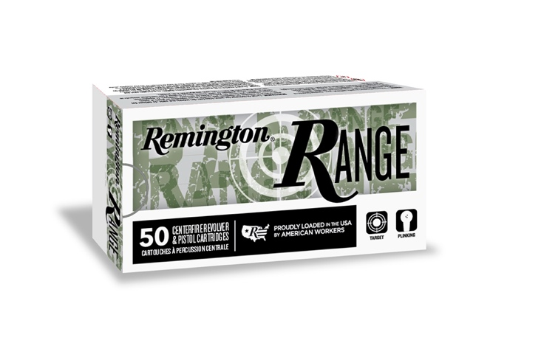

Remington Range joins the Remington Range Clean family, a recently introduced product that minimizes the shooter’s exposure to lead at the firing line. Loaded using high quality, factory fresh components, the easily reloadable Remington Range changes the shooting range game.

Key features include:
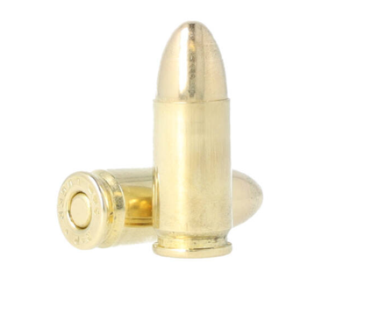
- Available in 50, 500, 600 and 1,000 round bulk packs
- Available in 9mm and 40 S&W
- Clean shooting Kleanbore priming
- Full metal jacket (FMJ) projectiles
- Temperature stable propellant for consistent velocity and performance
- MSRP: $24.99 - $251.99

Remington Range loads are now available for shooting enthusiasts across the country–all at the right price and ready for the range.

Find Remington ammunition at dealers nationwide and online. For more information on Remington ammunition and accessories, visit www.remington.com.

Press Release Contact: Jonathan Harling
Remington Public Relations
E-mail: remingtonammopr@murrayroadagency.com

About Remington
From muskets to modern day, generations of hunters and shooters have trusted Remington ammunition and accessories. Loaded in Lonoke, Arkansas by American workers, our wide array of pioneering sporting and hunting ammunition promises to get the job done every time the trigger is pulled. At Remington, we’re here for everyone who loads a round of ammo into a handgun, rifle, or shotgun.

Founded in 1816, Remington and America have fought and won wars, put food on millions of tables and brought countless generations together at the range and in the field. We are proud of each and every round that rolls off our factory line. A brand of outdoor sports and recreation company Vista Outdoor, Remington is bringing a renewed focus to ammunition, innovation, and quality – all while staying true to Remington’s legendary heritage and stature as an American icon.

