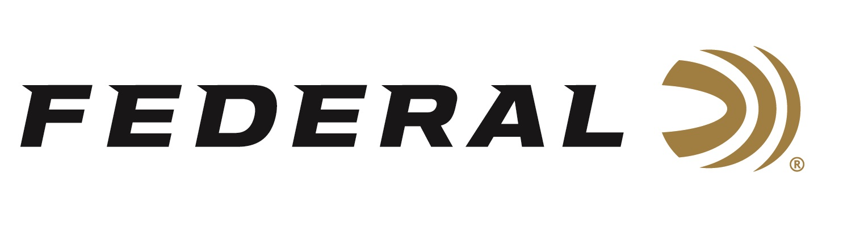

FOR IMMEDIATE RELEASE

Skeet Shooters on Team Federal Win Medals at the 2022 ISSF World Cup

ANOKA, Minnesota – April 7, 2022 – Team Federal congratulates its team members Austen Smith and Caitlin Connor for their medal performances in Skeet at the ISSF World Cup held in Lima, Peru, March 27 to April 7.

Federal Ammunition sponsored shooters Caitlin Connor and Austen Smith, along with Dania Jo Vizzi, captured gold in the Team Women Skeet event. These American athletes knocked off the Italians in the finals. Tokyo Olympic USA team member Austen Smith paired with Dustan Taylor to win silver in the Mixed Team Women Skeet event. Smith also claimed a silver in the Women Skeet competition.

“We congratulate all of our Team Federal athletes for their medals won at this prestigious, worldwide event,” said Federal Ammunition’s Vice President of Marketing Jason Nash. “All of our American factory workers have tremendous pride in manufacturing quality products that ultimately fuel athletes competing in shooting sports. We look forward to seeing more success from Team Federal and all our customers competing at many regional, national and international matches this year.”

Federal sponsors several American athletes who are preparing to bring home gold at all major international competitions. Overall, Team USA won eleven medals in the 10 events that were contested at this year’s ISSF World Cup. The breakdown was 4 gold, 3 silver and 4 bronze. Of those 11 medals, more than any other country, Federal sponsored shooters were part of eight of those medal winning performances in Skeet (Austen Smith and Caitlin Connor) and Trap (Kayle Browning and Derrick Mein).

Federal ammunition can be found at dealers nationwide or purchased online direct from Federal. For more information on all products from Federal or to shop online, visit www.federalpremium.com.

Press Release Contact: JJ Reich
Senior Manager – Press Relations
E-mail: VistaPressroom@VistaOutdoor.com

About Federal Ammunition
Federal, headquartered in Anoka, MN, is a brand of Vista Outdoor Inc., an outdoor sports and recreation company. From humble beginnings nestled among the lakes and woods of Minnesota, Federal Ammunition has evolved into one of the world's largest producers of sporting ammunition. Beginning in 1922, founding president, Charles L. Horn, paved the way for our success. Today, Federal carries on Horn's vision for quality products and service with the next generation of outdoorsmen and women. We maintain our position as experts in the science of ammunition production. Every day we manufacture products to enhance our customers' shooting experience while partnering with the conservation organizations that protect and support our outdoor heritage. We offer thousands of options in our Federal Premium and Federal® lines-it's what makes us the most complete ammunition company in the business and provides our customers with a choice no matter their pursuit.

